WALGA Climate Change Declaration Template

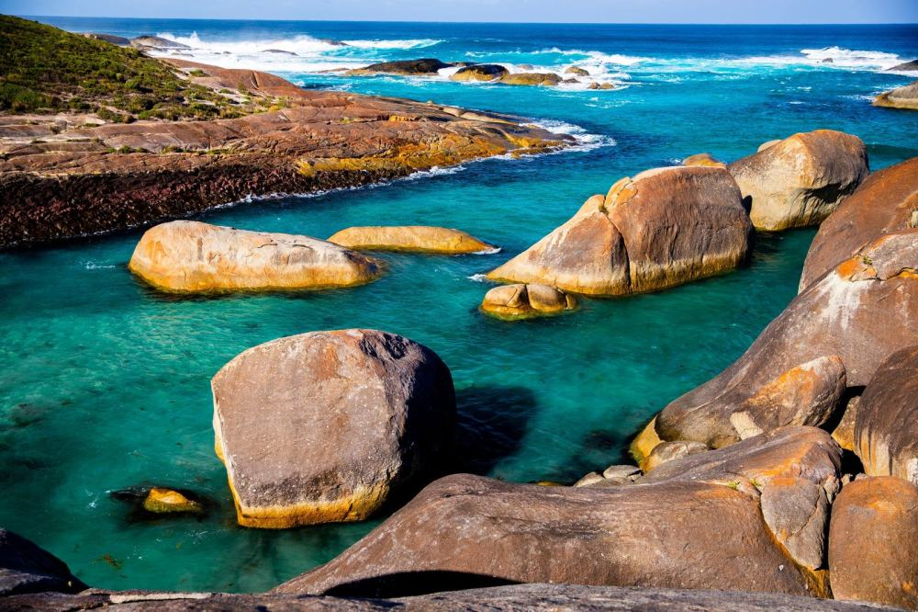
Image: Elephant Rocks, Denmark (Source: WALGA)

Acknowledgement
The WA Local Government Association (WALGA) acknowledges the Traditional Owners of the land and pays respects to Elders past, present and emerging.

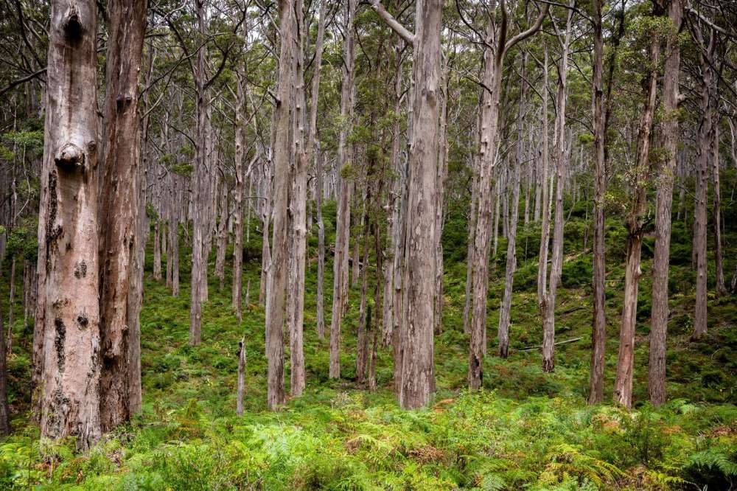
Image: Boranup Forest (Source: WALGA)
Table of Content
Using the Climate Change Declaration Template 3
Introduction 7
Declaration 7
Background 8
Role of Government 9
Progress to date 9
Commitments 10
Signatures 11
Climate Change Declaration Certificate 12

Using the Climate Change Declaration Template

This Climate Change Declaration template has been developed to assist Local Government to take action to manage the impacts of climate change (adaptation) and reduce greenhouse gas emissions (mitigation).

The template contains text in red that is intended to be edited by Local Governments to reflect their climate actions and commitments.

A Climate Change Declaration may be used as a first step in addressing climate change in Local Government. The Declaration is taken to Councils for endorsement and should connect to priorities in the Local Government’s Strategic Community Plan or Corporate Business Plan.

The Declaration provides a clear statement that the Local Government:

- Accepts the science behind climate change;
- Commits to adopting climate change adaptation and mitigation strategies; and
- Identifies a clear objective for signing a Climate Change Declaration.

This template is divided into five sections:

- An acknowledgement and declaration;
- Background;
- Commitments;
- Signatures; and
- A Climate Change Declaration Certificate template.

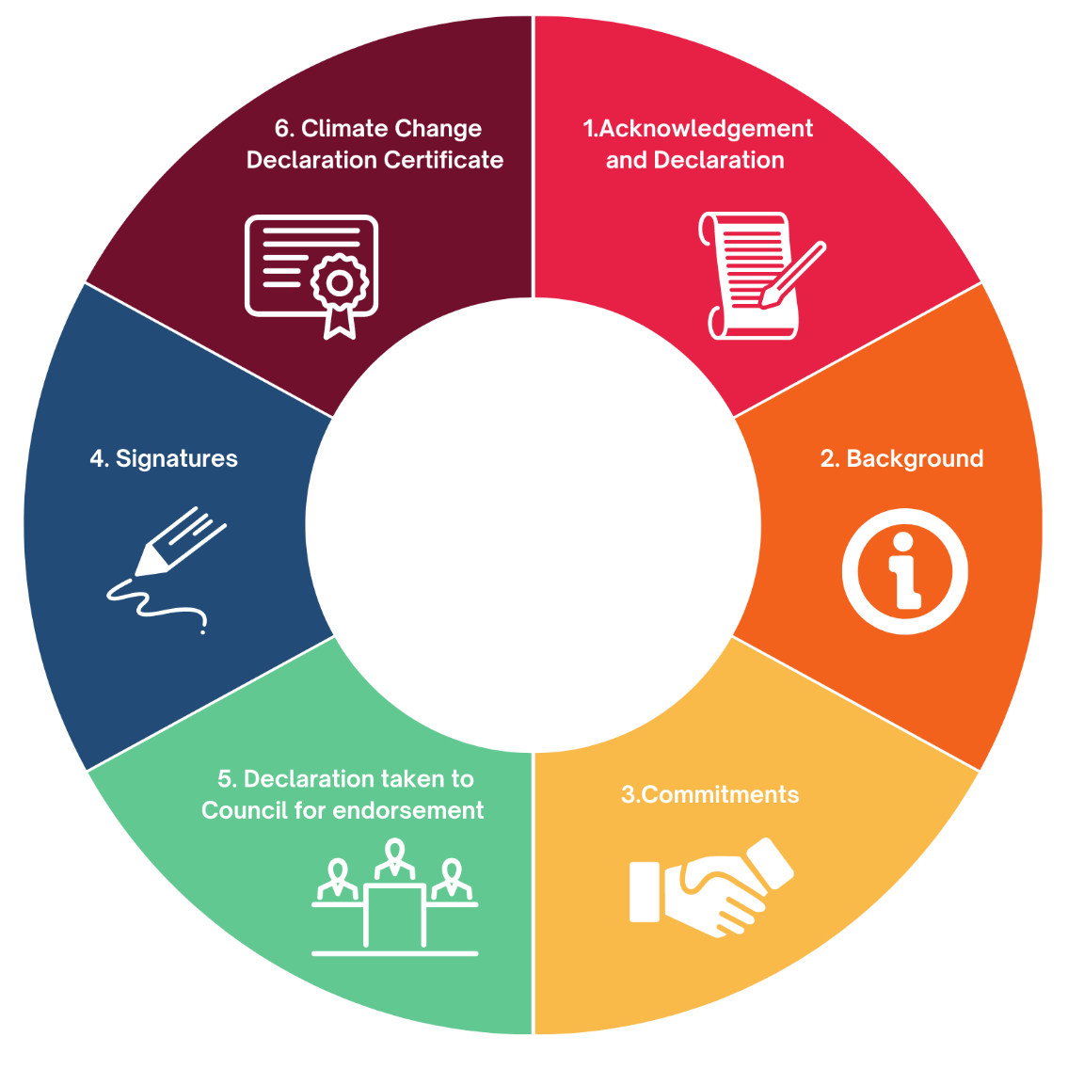

Figure 1: The Climate Change Declaration process

- Acknowledgement and Declaration

High level statements are provided that require an acknowledgement that climate change is occurring and a declaration from the Local Government that they support broad and high level climate action.

- Background

Background information on climate science is provided and the Local Government is required to identify projected changes to the climate relevant to the Local Government area. Information is also provided on the role of Local Government in addressing climate change and the Local Government is then required to provide a list of existing actions they are taking to respond to climate change.

- Commitments

The Local Government is required to provide a list of their commitments to take action on climate change. It is recommended that each Local Government should select their commitments carefully, as there is a clear expectation that these commitments will be followed through.

- Signatures
A space is provided for the signatures of the Mayor/Shire President of the Local Government and WALGA’s President. This demonstrates the commitment of the Councils to the actions outlined in the Declaration and WALGA’s endorsement.

- Climate Change Declaration Certificate

The final section contains a Climate Change Declaration Certificate template. The Certificate is a shortened version of the Local Government’s Climate Change Declaration and is intended to be displayed by the Local Government to demonstrate its commitment to climate action.

Local Governments may choose to send a Word document copy of their Climate Change Declaration to WALGA to be formatted and framed as a certificate. It will be formatted into an A3 size certificate with both the Local Government and WALGA logos displayed, framed by WALGA and returned to the Local Government for display.

Local Government signatories to the Climate Change Declaration provide evidence to support WALGA’s advocacy for appropriate funding and development of legislative mechanisms to support Local Government climate change adaptation and mitigation actions.

The Climate Change Declaration template begins on the next page.

Local Governments may choose to edit or delete previous pages including:
- WALGA Climate Change Declaration Template cover page
- WALGA Acknowledgement of Country
- Using this Climate Change Declaration template instructions.

Local Governments may also choose to remove WALGA’s header and footer and insert their own logo and templates.

Shire/City/Town of [insert]

Climate Change Declaration

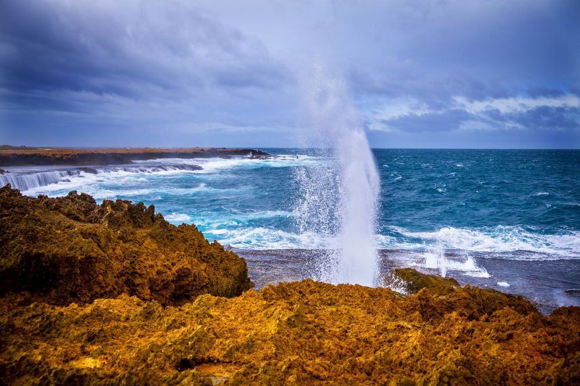
Image: Carnarvon Blowholes (Source: WALGA)

Image: Kalbarri Gorge (Source: WALGA)

Introduction
Climate change is having, and will continue to have, significant effects on the Western Australian environment, society and economy, with impacts felt at the Local Government level. The Shire/City/Town of [insert] acknowledges that human behaviours, pollution and consumption patterns have both immediate and future impacts on the climate and environment, and that as a Local Government it is part of our role to mitigate and manage these impacts on our community.
This Declaration establishes our position on climate change, and outlines our commitments to addressing climate change, which are further expanded upon in our [Corporate/Community/Adaptation/Mitigation Action Plans] or [insert title of other relevant documents here].
The Shire/City/Town of [insert] supports the environmental, social and economic benefits of addressing climate change immediately. We see an opportunity for Local Government to demonstrate leadership in climate change management at a community level and support the development of equitable and implementable State and Commonwealth strategies for climate change management.

Declaration
The Shire/City/Town of [insert] recognises that climate change is occurring, and that climate change will continue to have a significant effect on the Western Australia environment, society and economy.
We acknowledge the central role of Local Government in driving a successful climate response. Hence, we declare that we are committed to addressing climate change within our Local Government area, through the implementation of mitigation and adaptation strategies to minimise the effects on our community, environment and economy.
Our overall objective/s is to align to the Paris Agreement/demonstrate climate leadership/reduce our corporate/community emissions/build the resilience of our Shire/City/Town to climate change [insert other climate change related objectives for the Local Government].

Background
International scientific consensus is that climate change is occurring, and that it is driven by anthropogenic causes, with human activities having a profound impact on the concentration of greenhouse gas emissions since the start of the industrial revolution. Ultimately, these activities, such as the burning of fossil fuels, land clearing and agriculture, have increased greenhouse gas concentrations in the atmosphere, leading to changes in the climate system.
For the Shire/City/Town of [insert] projected changes to our climate in the future include:
[Only include relevant climate changes to the Local Government area from the list below, note that not all items must be included and that only those applicable to the region are recommended to be included]
- Further increase in temperatures, with more extremely hot days and fewer extremely cool days;
- More heat waves that will be longer and hotter;
- More frequent, extensive, intensive and longer‐lasting marine heatwaves;
- Ongoing sea level rise;
- Further warming and acidification of the oceans;
- A decrease in cool‐season rainfall across southern Australia, including the southwest of WA;
- Likely increase in wet season rainfall in the north of WA;
- More frequent, longer and more intense droughts across southern Australia, including the southwest of WA;
- More intense heavy rainfall throughout Australia, particularly for short‐duration extreme rainfall events (storms);
- An increase in the number of high fire weather danger days and a longer fire season for southern and eastern Australia;
- Fewer tropical cyclones, but a greater proportion of high‐intensity storms, with large variations from year to year; and
- Through a combination of many of these impacts, changes to biodiversity including increased species extinction.
These changes have the potential to impact our environment, assets and infrastructure in our Local Government area, and the health, safety and wellbeing of our people. We therefore need to plan for, and adapt to, these changes to ensure our Shire/City/Town remains a resilient and vibrant area.

Role of Government
As a signatory to the Paris Agreement under the United Nations Framework Convention on Climate Change and the United Nations Sustainable Development Goals, Australia has committed to taking action on climate change.
The Paris Agreement recognises the importance of engagement at all levels of government. As such, the management of climate-change risks in Australia is spread across the three tiers of government: Commonwealth, State and Territory, and Local.
The responsibility for Local Governments’ to mitigate the impacts of climate change is reflected in the Local Government Act 1995 (WA):
“In carrying out its functions a Local Government is to use its best endeavours to meet the needs of current and future generations through an integration of environmental protection, social advancement and economic prosperity. (Section 1.3(3))”.
As a Local Government our key responsibilities include administering relevant legislation to promote adaptation, mitigating climate risks and impacts to our community and assets as well as the delivery of our services to our community, collaborating with other Local Governments and with State and Territory Governments to manage regional impacts, and the facilitation of resilience building and adaptative capability in our local community.

Progress to Date
In order to respond to the impacts of climate change, the Shire/City/Town of [insert] has taken action by:
[Select from/add to the list below based on the existing strategies and/or work completed by the Shire/City/Town to respond to climate change]
- Developing a Climate Change Action Plan/Corporate and/or Community Adaptation Action Plan/ Corporate and/or Community Mitigation Action Plan
- Developing an Emissions Reduction Plan
- Developing a Climate Change/Emissions Reduction/Sustainability Strategy
- Undertaking a climate change risk assessment
- Adopting a net zero emissions/emissions reduction/renewable energy target
- Setting waste, electricity, gas and fuel etc. targets
- Reducing emissions from electricity/fleet/street lighting etc. by X/XX%

Commitments
The Shire/City/Town of [insert] commits from the date of signing to:
[Select from/add to the list below based on the Shire/City/Town’s commitments to respond to climate change. Please note that each Local Government should select what their commitments are carefully, as there will be a clear expectation that these commitments will be followed through.]
- Develop and implement a Climate Change Action Plan/Corporate and/or Community Adaptation Action Plan/ Corporate and/or Community Mitigation Action Plan.
- Set an appropriate emissions reduction target and work towards its achievement.
- Encourage and empower the local community and local businesses to reduce their greenhouse gas emissions and to adapt to the impacts of climate change.
- Support WALGA to work with State and Federal Government to ensure achievement of greenhouse gas emissions reduction targets as set out in key National and International agreements.
- Support WALGA to work with State and Federal Government to implement key actions and activities for climate change management at a local level.
- Work with key stakeholders within the Shire/City/Town/our community to ensure achievement of the actions set out in our Climate Change Action Plan/Corporate and/or Community Adaptation Action Plan/ Corporate and/or Community Mitigation Action Plan.
- Assess the locally specific risks associated with climate change and implications for our services, and identify areas where appropriate mitigation and/or adaptation strategies should be developed and implemented.
- Ensure that, at appropriate review intervals, our climate change Action Plans/policies/strategies are reviewed and amended to incorporate the latest climate science, and to reflect the climate change management priorities and progress achieved to date.
- Monitor the progress of our adaptation and/or mitigation actions and communicate our achievements to the Councils and Community.

Signatures
Signed:
Mayor/Shire President - Shire/City/Town of [insert]
Date:
Signed:
President - Western Australian Local Government Association
Date:

Climate Change Declaration Certificate

The Climate Change Declaration Certificate is a shortened version of the Local Government’s Climate Change Declaration and is intended to be displayed by the Local Government to demonstrate its commitment to climate action.

The Climate Change Declaration Certificate template (below) can be edited and used by Local Governments or emailed to WALGA’s Environment Policy team (environment@walga.asn.au) to be formatted into an A3 size certificate. WALGA’s Climate Change Declaration certificate will display both the Local Government and WALGA logos and be framed by WALGA for the Local Government to display.

Please ensure that an electronic or scanned copy of the Mayor/Shire President’s signature is included in the Word document copy before sending to WALGA. If using the Certificate template within the Local Government only, remove the signature line for WALGA President.

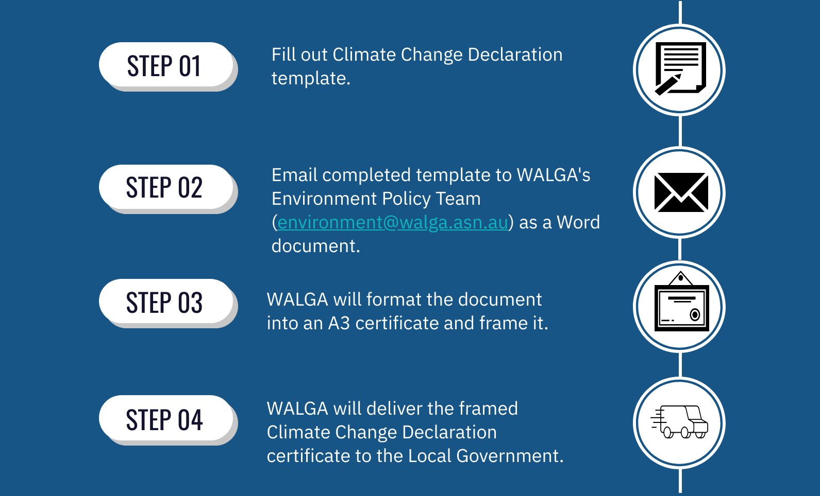
WALGA will cover the cost of producing the framed certificate.

Figure 2: Process for obtaining a Climate Change Declaration Certificate from WALGA.

The Climate Change Declaration Certificate template begins on the next page.

Local Governments may choose to copy and paste the following pages into a new document before sending to WALGA’s Environment Policy team to create a Climate Change Declaration Certificate or to use for internal purposes.

Climate Change Declaration

The Shire/City/Town of [insert] acknowledges that:

- Evidence shows that climate change is occurring;
- Climate change will continue to have significant effects on the Western Australian environment, society and economy, and the Local Government sector.
- Human behaviours, pollution and consumption patterns have both immediate and future impacts on the climate and environment.
- As a Local Government, it is part of our role to mitigate and manage the impacts of climate change on our community.

The Shire/City/Town of [insert] supports the:
- Environmental, social and economic benefits of addressing climate change immediately.
- Opportunity for Local Government to demonstrate leadership in climate change management at a community level.
- Development of equitable and implementable State and Commonwealth strategies for climate change management.

The Shire/City/Town of [insert] commits from date of signing to:
[Select from/add to the list below based on the Shire/City/Town’s commitments to respond to climate change. Please note that each Local Government should select what their commitments are carefully, as there will be a clear expectation that these commitments will be followed through.]
- Develop and implement a Climate Change Action Plan/Corporate and/or Community Adaptation Action Plan/ Corporate and/or Community Mitigation Action Plan.
- Set an appropriate emissions reduction target and work towards its achievement.
- Encourage and empower the local community and local businesses to reduce their greenhouse gas emissions and to adapt to the impacts of climate change.
- Support WALGA to work with State and Federal Government to ensure achievement of greenhouse gas emissions reduction targets as set out in key National and International agreements.
- Support WALGA to work with State and Federal Government to implement key actions and activities for climate change management at a local level.
- Work with key stakeholders within the Shire/City/Town/our community to ensure achievement of the actions set out in our Climate Change Action Plan/Corporate and/or Community Adaptation Action Plan/ Corporate and/or Community Mitigation Action Plan.
- Assess the locally specific risks associated with climate change and implications for our services, and identify areas where appropriate mitigation and/or adaptation strategies should be developed and implemented.
- Ensure that, at appropriate review intervals, our climate change Action Plans/policies/strategies are reviewed and amended to incorporate the latest climate science, and to reflect the climate change management priorities and progress achieved to date.
- Monitor the progress of our adaptation and/or mitigation actions and communicate our achievements to the Councils and Community.

Signed:
Mayor/Shire President - Shire/City/Town of [insert]
Date:
Signed:
President - Western Australian Local Government Association
Date:

