Local Government Animal Welfare in Emergencies Grant Program
Application Form
The Animal Welfare in Emergencies Grant Program is funded by the Department of Primary Industries and Regional Development (DPIRD) to promote Preparedness, Response and Recovery capacity building for animal welfare in emergencies in Local Governments.
Research indicates that the human-animal bond plays a critical role in a person’s compliance with emergency response directions, such as evacuating and preparation activities, and can lead to risk-taking behaviour causing dangerous or fatal consequences. The Grant Program seeks to improve the animal’s chances of survival and recovery, and to the safety and resilience of communities, through preparedness activities.
The Grants Program also aims to support the State Support Plan-Animal Welfare in Emergencies (2019) which:
- defines the roles and responsibilities for animal welfare in response to, and to recover from, emergencies for all hazards
- provides a framework for the coordination between government agencies, non- government agencies, industry, the community and owners or carers of animals
Eligible applicants can apply for small grants of between $5,000 and $10,000 (ex GST) per Local Government. A collaborative grant of up to $5,000 (ex GST) per number of Local Governments within the collaboration is available. For example, a collaboration of 5 Local Governments=a maximum grant allocation of $25,000 (ex GST).
To apply for the Animal Welfare in Emergencies Grants for Local Government program, please fill out and submit the application form below.
The Program Guidelines are available on the WALGA website.
For further questions, please contact the WALGA Resilient Communities Team.
Instructions
If your computer opens this document as a read-only document, go to the ‘view’ tab and select ‘edit document’.
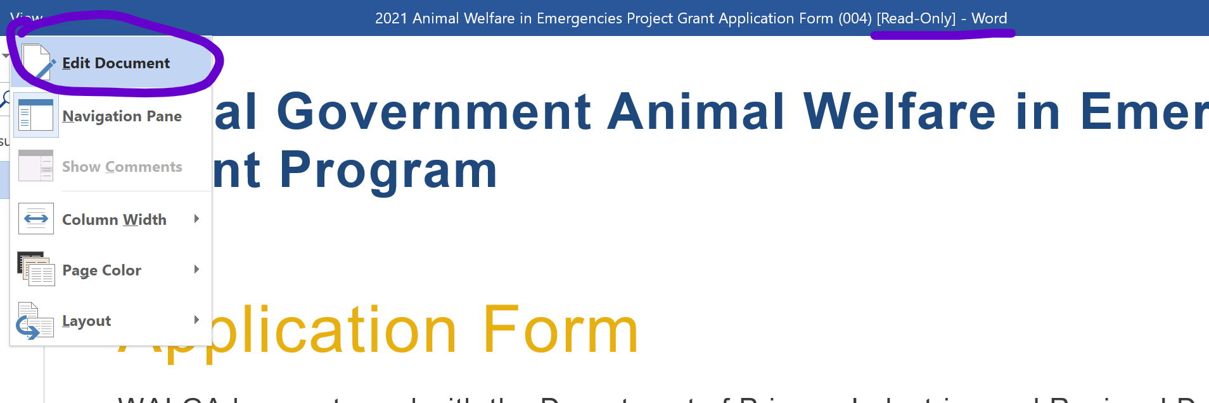
Once you have selected ‘edit document’, please save the word document on your desktop before filling in the fields.
Once the fields are completed, save the word document, attach it to an email and send it to em@walga.asn.au. Alternatively, select the ‘file’ tab, click ‘share’ and select ‘email’.

Applicant Details
- What is the name of your Local Government?
Click or tap here to enter text.
- Has your CEO given permission to apply for this grant?

Click or tap here to enter text.
- Contact person (this is the lead applicant who will be contacted if further information is required)
Name Click or tap here to enter text.
Position Title Click or tap here to enter text.
Email Address Click or tap here to enter text.
Phone Number (work) Click or tap here to enter text.
Local Government Click or tap here to enter text.
Postal Address Click or tap here to enter text.
City/Town Click or tap here to enter text.
Postal Code Click or tap here to enter text.

- Contact person (*this is only required if applying for a collaborative grant)
Name Click or tap here to enter text.
Position Title Click or tap here to enter text.
Email Address Click or tap here to enter text.
Phone Number (work) Click or tap here to enter text.
Local Government Click or tap here to enter text.
Postal Address Click or tap here to enter text.
City/Town Click or tap here to enter text.
Postal Code Click or tap here to enter text.

- Contact person (*this is only required if applying for a collaborative grant)
Name Click or tap here to enter text.
Position Title Click or tap here to enter text.
Email Address Click or tap here to enter text.
Phone Number (work) Click or tap here to enter text.
Local Government Click or tap here to enter text.
Postal Address Click or tap here to enter text.
City/Town Click or tap here to enter text.
Postal Code Click or tap here to enter text.

- Contact person (*this is only required if applying for a collaborative grant)
Name Click or tap here to enter text.
Position Title Click or tap here to enter text.
Email Address Click or tap here to enter text.
Phone Number (work) Click or tap here to enter text.
Local Government Click or tap here to enter text.
Postal Address Click or tap here to enter text.
City/Town Click or tap here to enter text.
Postal Code Click or tap here to enter text.

- What is your Local Government(s) Band? (*Local Government Band Allocations can be viewed here)
☐ Band 1 or 2
☐ Band 3 or 4
☐ Both Bands (for collaborative grants)

- Is this project a collaboration between multiple Local Governments?
☐ Yes
☐ No
- If this project is a collaboration between multiple Local Governments, please list the Local Governments.

Click or tap here to enter text.
- What size grant are you applying for?
- Grants are available up to a maximum of $10,000 (ex GST).
- A collaborative grant of up to $5000 (ex GST) per number of Local Governments within the collaboration is available - i.e. a collaboration between 5 Local Governments = a maximum grant allocation of $25,000 (ex GST).
Please enter the amount you are applying for in numerical values.
Click or tap here to enter text.

- Local Governments are required to provide a financial and/or in-kind contribution to the project. Please explain whether your Local Government contribution will be in-kind, financial or both and what your contribution will be.
The contribution required is based on which Local Government band you are from and is explained below:
- Band 1 & 2 Local Governments must demonstrate a 50 (Grant): 50 (Local Government) contribution
- Band 3 & 4 Local Government must demonstrate a 75 (Grant): 25 (Local Government) contribution
- A collaborative grant application must demonstrate a 75 (Grant): 25 (Local Government) contribution
In a collaborative grant the contribution can be split across involved Local Governments, or provided by a single Local Government within the collaboration.
Click or tap here to enter text.

Project Overview
The Assessment Criteria for Grant funding are as listed below. Please note all assessment criteria will be weighted equally when assessing applications.
1. Animal welfare outcome - the extent to which the project will help communities to prepare for, and respond to, the impacts of emergency situations on animal welfare.
2. Community engagement and capacity building - The extent to which the project engages and builds the capacity of the Local Governments and broader community and support resilience in a time of crisis.
3. Risk management - This criteria refers to the extent to which the project addresses any of any risks previously identified in your Local Government/s' emergency risk assessment process.
4. Value for money - The project represents good value for money by delivering multiple outcomes, high public benefit and reasonable costings.
5. Demonstrated need and community and public benefit - Alignment with Strategy, Plan, or other statement identifying the need for this project or activity, and the community and public benefit to be delivered by the project.

- Project Title
Click or tap here to enter text.
- What best describes the project you would use the grant for?
☐ Development or review of a Local Plan for Animal Welfare in Emergencies (PAWE) and/or arrangements
☐ An exercise or training opportunity in capabilities for animal welfare in emergencies
☐ A community education engagement or education program
☐ Procurement of equipment to support animal welfare in emergencies
☐ Other (propose a new initiative):
Click or tap here to enter text.

- Project Description This may be used to promote the project on WALGA’s website and in media release. (maximum 300 words)
Click or tap here to enter text.

Addressing the Criteria
Please respond in 300 words or less to each question. Please note all assessment criteria will be weighed equally when assessing applications.
- How will this project address Assessment Criteria 1 - Animal Welfare Outcome?
Click or tap here to enter text.

- How will this project address Assessment Criteria 2 - Community engagement and capacity building
Click or tap here to enter text.

- How will this project address Assessment Criteria 3 - Risk management?
Click or tap here to enter text.

- How will this project address Assessment Criteria 4 - value for money
Click or tap here to enter text.

- How will this project address Assessment Criteria 5 - Demonstrated need and community and public benefit?
Click or tap here to enter text.

General Questions
Please note the following questions have been asked to provide the assessment panel with broad information about your Local Government(s), and will not be used to penalise Local Government(s) who have not had the capacity to prepare for animal welfare in emergencies.
- When were your Local Emergency Management Arrangements (LEMA) last updated?
Click or tap here to enter text.
- Does your Local Emergency Management Arrangements (LEMA) include animal welfare in emergencies considerations?
☐ Yes
☐ No
☐ Other (If you are applying for a collaborative grant, please specify whether each individual Local Governments' LEMA includes animal welfare in emergencies consideration)
Click or tap here to enter text.
- When did your Local Government(s) last undertake an emergency risk assessment?
Click or tap here to enter text.
- Did your Local Governments last emergency risk assessment include animal welfare in emergencies?
☐ Yes
☐ No
☐ Other (If you are applying for a collaborative grant, please specify whether each individual Local Governments' LEMA includes animal welfare in emergencies consideration)
Click or tap here to enter text.

- What are the risks you have identified for your jurisdiction? Please provide a brief description under the following headings hazards, communities, animals/animal industries, and other.
Click or tap here to enter text.

- What is your current preparedness for animal welfare in emergencies? Please choose from the following and multiple answers may be chosen for collaborative grants.

☐ No plan / preparedness: No arrangements are documented for how your local government would consider animal welfare in an emergency.
☐ Minimal preparedness: Animal welfare is mentioned within your local government emergency arrangements, however the responsibility is delegated to another organisation or individual (such as Rangers or the Owner or Carer) and no further details are included within your plans.
☐ Moderate preparedness: Policies/plan/procedures include reference to animal welfare considerations in emergencies in simple detail. General information, such as contact lists and resources, are available but are not detailed as a standalone plan or integrated into emergency arrangements.
☐ Adequate preparedness: Animal welfare in emergencies is documented within a dedicated plan outlining roles and responsibilities with supporting tools and resources such as forms, contacts, services/resource availability.
☐ Integrated preparedness: Your Local Government’s arrangements for animal welfare have been integrated fully into your emergency management arrangements. Animal welfare considerations are identified as part of the greater emergency preparedness, response and recovery i.e. captured within communication plans, evacuation plans, exercise plans and recovery plans.

- End of Application Form -

Upon completion of this form, save the word document onto your desktop, attach it to an email and send it to em@walga.asn.au

