Emergency Waste Management Plan [Shire/Town/City of ….]
Note: This template is intended to be completed by Local Governments. The template including examples is available on the WALGA Website. Text in red is instructional and should be deleted once the Plan is finalised.
- Hazards and waste types
- For each of the pairings, choose one that is most relevant to your Local Government.
- Once identified, outline what associated types of waste you might expect to see (Appendix 1 and 2 can be used to cross reference and verify)
Hazard | Associated types of waste
- Fire OR Cyclone

- Air crash OR Collapse

- Animal & plant biosecurity OR Human epidemic
- Flood OR Marine oil pollution
Source of Information: Insert where information was sourced from.

- Understanding and mapping your environment
Built functional area
- Against these facility types, identify key structures present in your Local Government.
- What specific risks do they present for waste management?
Facility type | Key Structures | Waste-related Risk
Local Government
□ Admin/Civic centre
□ Library
□ Aquatic centre
□ Recreation centre
□ Theatre
□ Sporting facilities
□ Childcare
□ Operations depot
□ Waste facility
□ Airport
□ Commercial properties
Roads/bridges
Schools
Hospitals
Prisons
Police stations
Fire stations
Waste facilities
Public housing
Private Residential
Commercial / Industrial
□ Petrol stations
□ Power stations
□ Water pump stations
□ Gas pipeline booster stations
□ Chemical/industrial processing plant
□ Port operations
□ Freight handling operations
□ Wastewater treatment plant
□ Abattoir
□ Wind farm
□ Solar farm
Other Government facilities
Source of Information: Insert where information was sourced from.
Environment functional area
- Identify vegetation complexes in the Local Government.
- What specific risk do they present for waste management?
Reserve ownership | Key Areas | Waste-related Risk
Local Government
State Government
Shared ownership with traditional owners
Private
Source of Information: Insert where information was sourced from.
- Predicting waste
- What amount and type of waste are likely to be generated by emergency events?
- Working with three of your selected hazards from Section 1, use the waste calculator to forecast approximate amounts for a chosen severity of emergency, e.g. Fire with 30 residential houses lost.
Note: when entering data into the waste calculator, it is better to overestimate than underestimate amounts.
Hazard & scenario | Amount/type of waste
Source of Information: Insert where information was sourced from.
- Special or unique considerations for your Local Government
- What are limiting factors / issues for your Local Government?
Source of Information: Insert where information was sourced from.

- Staff Capacity and Local Government Equipment
- What is the level of staff experience, knowledge and capacity to deal with emergency waste?
- What equipment, at a broad level, does the Local Government have which could deal with extra waste generated?
Staff knowledge/capacity – current number of staff and their capacity
Equipment – what type of equipment does the Local Government have which could help with managing waste.
Source of Information: Insert where information was sourced from.
- Recovery/Disposal Options
- What are the current recovery/disposal options in the Local Government or Region?
- What is the current capacity of contractors and waste facilities and how could this be scaled up in an emergency?
- Which scenarios, from Section 3, could the contractor/facilities deal with?
- Are there types of waste that could not be handled locally?
- Are there potential waste materials which will require special conditions for local disposal e.g. asbestos?
- Will these waste types require external assistance or additional communication to residents?

Recovery / disposal options | Capacity – current / future | Scenario
□ Waste contractors
□ Local Government landfill
□ Private Sector landfill
□ Waste Water facility
Temporary waste sorting/transfer locations
Type of space | Location | Licence requirement | When to use
□ Hardstand  □ Warehouse/shed  □ Oval/public open space | Eg Hardstand at Shire depot | Eg interim amendment to facility licence | Eg Sorting and temporary storage of C&D waste before recovery or disposal
Source of Information: Insert where information was sourced from.
- Governance
- Who needs to know about what? What are the key roles in your Local Government, what is their responsibility and how are they linked into the Emergency Management structure?
Role | Responsibility / link to EM Structure
Source of Information: Insert where information was sourced from.

- Communications
- What is your communications plan / material for waste management?
- Can you pre-draft emergency guidance for the community?
- Should there be specific messaging for vulnerable members of the community? E.g. advising how to handle asbestos, and where you can dispose (including advice not to mix hazardous materials into the FOGO system).
- Do you have a Community Risk and Resilience Profile – understanding the needs, risks and strengths to guide communications?
Your communications plan should consider contingencies in the case of power/systems interruptions and how information will be disseminated. Consider simple communications and key messages for the potential types of waste and emergency events.
Topics | Timing | Communication material / pathways | Key personnel

- Funding
What decisions need to be made about funding?
For Local Government there are decisions regarding costs of services and also avenues for funding.
Area | Decision Point | Local Government Decision
Community | Under what circumstances, and for how long, will Local Government waive tip fees / provide free collection?
Funding | Will funding be sought from the National Emergency Funding? If so, ensure:  - Geotagged photos of waste (before / after)  - Setting up separate cost centres for emergency events  - Effective record keeping – ensure that software has a separate category for this waste  - Understanding of what is eligible / not eligible  (if so, ensure that evidence collection is undertaken).
Procurement | Are preapprovals in place or have preferred suppliers been identified?

Appendix 1: Waste Types
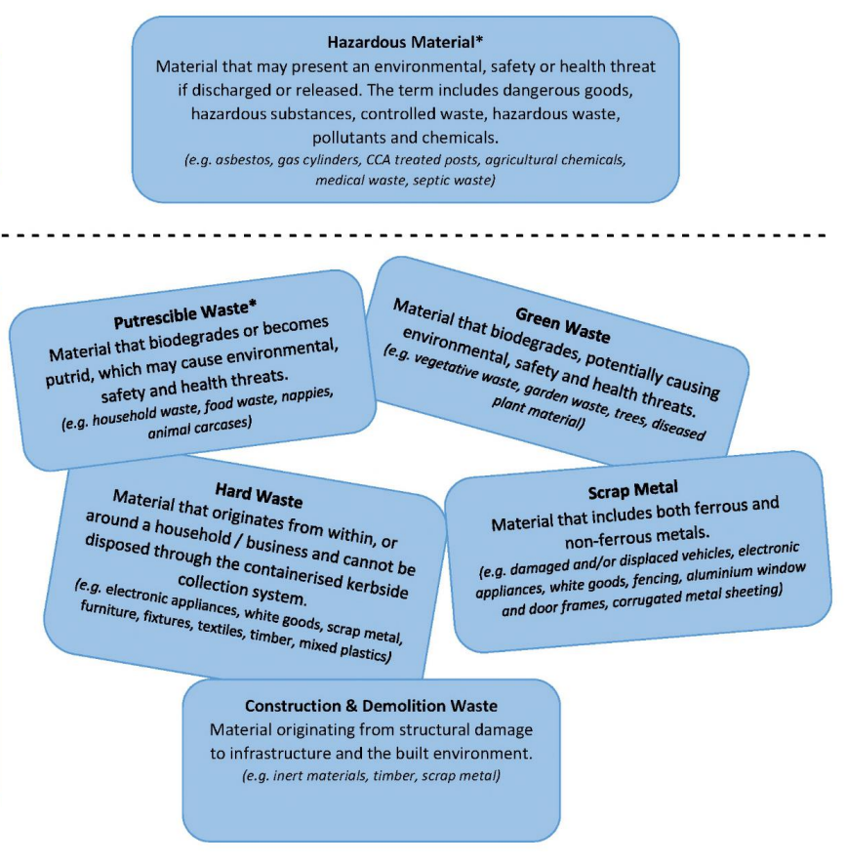

Appendix 2:
