Emergency Waste Management Plan Template
Background
There have been a range of situations in Western Australia where recovery efforts have been hampered by challenges associated with emergency waste management. Ineffective emergency waste management has the potential to significantly delay recovery efforts, present a considerable risk to human health and the environment and increase the costs of recovery. Effective planning for waste likely to be generated by emergency events can assist in addressing this issue. This plan helps local governments to think through, at a high level, the likely types of waste that could be generated and consequent considerations and management options to explore.
- Hazards and waste types
For each of the below pairings, choose one that you feel is more likely to affect your Local Government. Once identified, outline what associated types of waste you might expect to see. Appendix 1 and 2 can be used to cross reference and verify.
Hazard | Associated types of waste
- Fire OR Cyclone

- Air crash OR Collapse

- Animal & plant biosecurity OR Human epidemic
- Flood OR Marine oil pollution
Source of Information: Appendix 1 and 2, Local Emergency Management Risk Assessment Profile and DFES District Emergency Management Advisors
Rationale: the type of hazard can influence the type, variety and volume of waste generated in broad terms – e.g. flood = widespread green waste, fire = localised construction and demolition waste.
Example:
Hazard | Associated types of waste
- Fire OR Cyclone | - Specific areas: hazardous, construction and demolition, scrap metal  General – C&D, scrap metal  In vegetation – limited waste generation, minimal impact, clearing paths only.

- Understanding and mapping your environment
Built functional area
Against these facility types, list any key structures actually present in your Local Government. Once identified, what specific risks do they present for waste management?
Facility type | Key structures | Waste-related Risk
Local Government

□ Administration/Civic centre
□ Library
□ Aquatic centre
□ Recreation centre
□ Theatre
□ Sporting facilities
□ Childcare
□ Operations depot
□ Waste facility
□ Airport
□ Commercial properties

Roads/bridges
Schools
Hospitals
Prisons
Police stations
Fire stations
Waste facilities
Public housing
Private Residential
Commercial / Industrial

□ Petrol stations
□ Power stations
□ Water pump stations
□ Gas pipeline booster stations
□ Chemical/industrial processing plant
□ Port operations
□ Freight handling operations
□ Wastewater treatment plant
□ Abbatoir
□ Wind farm
□ Solar farm

State Government, other
Source of information: Local Government Asbestos Register, DWER Prescribed Premises Licence search & Australian Business Registry, Local Emergency Management Committee (LEMC) and Local Government Infrastructure Team, Bushfire management plan
Rationale: This helps to determine specific waste-related risks (including hazardous risks) of key built infrastructure in the LGA.
Example:
Facility type | Key structures | Waste-related Risk
Commercial / Industrial | Petrol station, agricultural businesses, automative services, manufacturing plants. | Licenced facilities, businesses with chemicals or processing hazardous material.
State Government | Hospital | Medical waste
Private residential | Single houses, tenement blocks | Asbestos (year of construction) and household chemicals

Environment functional area
Identify vegetation complexes in the Local Government. Outline what risk they present for waste management.
Reserve ownership | Key Areas | Waste-related Risk
Local Government
State Government
(multi jurisdictional)
Shared ownership with traditional owners
Private
Source of Information: Local Government records, urban forest mapping, local knowledge, Aboriginal Cultural heritage register, Landgate online aerial photography etc.
Rationale: This helps to estimate quantity of green waste, and to identify the likelihood of subsequent impacts on road access and required resources to clear public areas and road reserves in recovery.
Example:
Facility type | Key structures | Waste-related Risk
Local Government | Public Park x 4 | Clearing trees for access to open space
State Government | National park | Clearing trails, access routes, removing damaged signage
Private | Mostly farming land, no special requirements any issues managed by owners.

- Predicting waste
What volume and type of waste are likely to be generated by emergency events? Working with three of your selected hazards from Section 1, use the waste calculator to forecast approximate volumes for a chosen severity of emergency, e.g. Fire with 30 residential houses lost. Note: when entering data into the waste calculator, it is better to overestimate than underestimate volumes.
Hazard & scenario | Amount/type of waste
Source of Information: Section 1 (type of hazard), Section 2 (key structures), and Appendix 3 (waste calculator).
Rationale: This approach provides the Local Government with an opportunity to road test the waste calculator for potential scenarios, gaining insights on how much waste is likely to be generated. This information can guide decisions on how the Local Government handles the waste and any subsequent actions, including when they need to seek external assistance in handling necessary logistics.
Example:
Hazard & scenario | Associated types of waste
- Small fire, destroys 30 houses and 8 sheds. | Use waste calculator
- Light aircraft crash, destroys 3 houses, 1 shed, 1 convenience store, and 1 local road. | Use waste calculator
- Large animal biosecurity outbreak, with 250 head of cattle needing to be put down. | Use waste calculator

- Special or unique considerations for your Local Government
What are limiting factors / issues for your Local Government?
Source of Information: LEMA and local knowledge.
Rationale: to identify anything which, above and beyond, will influence the response and access to emergency waste management options.
Example: limited seasonal accessibility, remoteness, limited access (e.g. one way in / out), densely populated industrial zones.
Example:
Kimberley Floods
The Kimberley floods severely impacted landfill access and waste management:
- Impassable Roads: Floodwaters made roads to the landfill impassable, necessitating a temporary waste holding area. There was one way in and one way out of the landfill.
- Bridge Cut-off: Homes east of town couldn't have waste picked up by the local government due to a cut-off bridge. Neighbouring Local Governments had to step in, making over 250km trips each way.
- Landfill Capacity: The landfill was nearing capacity before the event. The increased waste from the floods would have caused it to reach capacity, leading to waste diversion.
These challenges required significant coordination and interim solutions to manage the waste effectively.

Staff Capacity and Local Government Equipment
What is the level of staff experience, knowledge and capacity to deal with emergency waste?
What equipment, at a broad level, does the Local Government have which could deal with extra waste generated?
Staff knowledge/capacity – current number of staff and their capacity
Equipment – what type of equipment does the Local Government have which could help with managing waste.
Source of Information: Human Resources section of Local Government, LEMA, assets register and direct discussion with staff/contractors.
Rationale: Mapping the broad capacity of the Local Government to respond, or when they will need external assistance (and the type/amount of assistance). If surrounding Local Governments are not as well resourced, consider convening a joint committee to assist in managing the event. This could include sharing resources between councils and having in place preplanned solutions to local problems.
Example:
Staff knowledge/capacity – current number of staff and their capacity | 8 staff at landfill, 20 plus in P&G and works team – all competent in machinery
Equipment – what type of equipment does the Local Government have which could help with managing waste. | Array of loaders, compactors, graders, backhoes, earthmoving equipment  Hook lift trucks, prime movers

- Recovery/Disposal Options
- What are the current recovery/disposal options in the Local Government or Region?
- What is the current capacity of contractors and waste facilities, and how could this scale up in an emergency?
- Which scenarios, from Section 3, could the contractor/facilities cope with? Are there types of waste that could not be handled locally?
- Are there potential waste materials which will require special conditions for local disposal eg asbestos? Will these require external assistance or additional communication to residents?
Recovery / disposal options | Capacity – current / future | Scenario

Temporary waste sorting/transfer locations
Type of space | Location | Licence requirement | When to use
□ Hardstand  □ Warehouse/shed  □ Oval/public open space | Eg Hardstand at Shire depot | Eg interim amendment to facility licence | Eg Sorting and temporary storage of C&D waste before recovery or disposal

Source of Information: DWER Prescribed Premises Licence search, Controlled Waste Tracking System and Australian Business Registry, Guidance on establishing temporary storage/sorting sites.
Rationale: mapping out what solutions are available will provide the Local Government an understanding of when they will be able to manage waste locally, and when external solutions will be required. For any emergency waste management solutions where the Local Government does not have operational control, direct engagement with providers will be required to ensure they have capacity and capability to take material; ideally an agreement will be in place with the provider – outlining terms and conditions for use of the facility, waste type, amount and form required for acceptance.
Example:
Recovery / disposal options | Capacity – current / future | Scenario
Waste collectors
Local Governments landfill | Landfill Regulated, max 5,000 tonnes per annum – currently taking 1,000 tonnes. Small asbestos pit – very limited capacity. | Small and potentially medium – but would mean no capacity for anything else that year. Would have to consider alternative site for asbestos as could not deal with anything more than 1 house.
Regional landfill – private sector
Waste-water facility
Temporary storage/sorting

- Governance
Who needs to know about what? What are the key roles in your Local Government, what is their responsibility and how are they linked into the Emergency Management structure?
Role | Responsibility / link to EM Structure
Rationale: Ensuring clear roles and responsibilities and lines of communication is essential. In emergency events the usual reporting lines / processes and structures are likely to be different, therefore it is essential to have these mapped.
Example:
Role | Responsibility / link to EM Structure
Manager Environment and Waste (or equivalent) | Responsible for implementing Emergency Waste Management plan
Executive Management Team | EMT convene and set up working group with appropriate manager responsible
Emergency Management Team | Link into DFES etc, coordinate with agencies
Manager Health Rangers and Emergency Services | Provide updates to exec team, responsible for implementing plan
Manager Finance/Procurement | Advise on and approve preferred suppliers/fast track procurement process

- Communications
What is your communications plan / material for waste management? Can you pre-draft emergency guidance for the community? Should there be specific messaging for vulnerable members of the community? E.g. advising how to handle asbestos, and where you can dispose (including advice not to mix hazardous materials into the FOGO system). Do you have a Community Risk and Resilience Profile – understanding the needs, risks and strengths to guide communications?
Your communications plan should consider contingencies in the case of power/systems interruptions and how information will be disseminated. Consider simple communications and key messages for the potential types of waste and emergency events.
Topics | Timing | Communication material / pathways | Key personnel
Rationale: It is important for the Local Government to think through what they will communicate, at which stage of the process and how that information will need to be distributed. Depending on the type of waste and emergency event there may be very specific requirements.
Example:
Topics | Timing | Communication material / pathways | Key personnel
Asbestos disposal | ASAP, once asbestos has been identified as present | Pre-written statements, distributed on social media, radio, leaflets, posters. | Comms team, incident manager

- Funding
What decisions need to be made about funding?
- For the community – when will Local Government waive tip fees / provide free collection and for how long
- For Local Government – funding through national Emergency funding (ensure evidence collection – geotagged photos)
- Information available on when an event is declared eligible for national/state funding
- Include key information needed for funding applications as a table eg stockpiles before and after
- Tracking of waste trucks and disposal
- Information available to the team on which cost centres/GL codes can be used for emergency waste operations
- Procurement pre approval in place or preferred suppliers/contractors identified
- Operational changes may need to be made to accommodate funding process - eg approach to hard waste
- Record keeping changes – eg recording emergency waste brought to landfill separately from regular collections, update software, footage from security cameras
- Understanding insurances for private property, accessing register – range of insurances

- Resource / Additional matters to include
- Exemptions on using ovals etc for sorting – what are the guidelines on licensed activities rather than sites, what is the checklist and what would they require
- DWER have ‘fast track’ licence amendment option – include how to link and what information is needed
- Guidance on asbestos, hazmat, medical / animal / quarantine waste
- Local Governments Regulatory Requirements and Powers – WALGA Report on Legislation.

Appendix 1: Waste Types
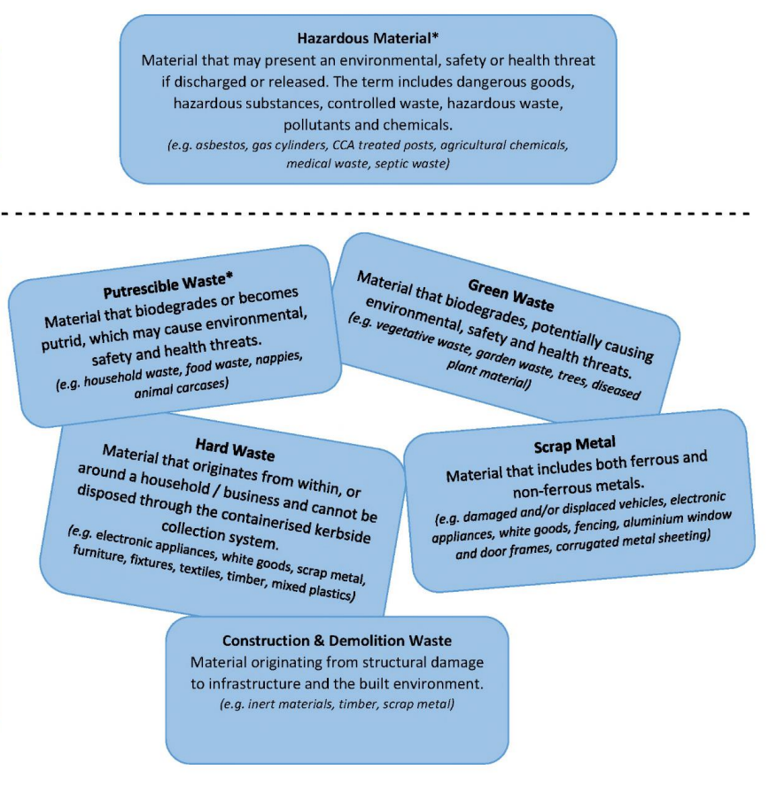

Appendix 2:
