Natural Area Initial Desktop Assessment

Date of assessment |  |  |  |  |  |  |  |  |  | Reserve or Lot Number:
Name of area
Location (address/street name incl. suburb, nearest street corner, suburb/locality)
Set up a GIS project with datasets listed in Appendix 6. For reserves with multiple attributes identified, it can be helpful to create a map showing the location, reserve boundaries, mapped vegetation types, wetlands, ecological linkages and other features. Sensitive information, like locations of threatened flora and fauna records needs to be protected and excluded from any publicly available documents.
Area (ha) |  |  |  |  |  |  |  |  |  |  |  | Perimeter (m)
Perimeter (m) to area (m²) ratio |  |  |  |  |  |  |  |  |  |  |  | Priority for Further Investigation
Ownership (Local Government / Other Govt / Private) if known
Land Manager
RNTBC or other relevant Aboriginal Representative Organisation
Reserve Vesting Purpose
Region Scheme Reservation or Zoning (where applicable)
Local Planning Scheme Reservation or Zoning
Protection Status (circle) |  |  |  |  |  |  | none / Crown reserve with conservation vesting purpose / conservation covenant / conservation type zone / Bush Forever
Current land use
Management Plan |  |  |  |  |  |  |  |  |  |  |  |  |  |  |  |  | yes/no
Title/Author/Year
Previous assessment using the Natural Area Initial Templates. If applicable, list the year of assessment

Recognised International/ National/ State/ Regional Conservation Value |  |  |  |  |  |  |  | yes/no
Specify
Mapped Vegetation Complex/es
Mapped Soil Type/s (if mapping available)
Mapped wetland/s: |  |  |  |  |  |  |  |  | yes/no
Wetland Management Category (where available): |  |  |  |  |  |  | CC/RE/MU
Is it a mapped floodplain area? |  |  |  |  |  |  | yes/no
Potential Reference Sites and/or Survey Plots (e.g. Bush Forever Sites; Jarrah Forest, Crown Reserves).
Existing biological information for area or for potential Reference Sites (reports/ surveys/ species lists e.g. information published at the online Index of Biodiversity Surveys for Assessments)
Part of an Ecological Linkage |  |  |  |  |  | yes/no/not assessed
Time since isolation from other natural areas |  |  |  |  |  | <5 years/ 5 - 20 years/ >20 years
(consult local community, historical aerial photography)

Does it contain any mapped Threatened Ecological Communities? |  |  |  |  |  |  |  | yes/no
Specify:
Does it contain any records of Threatened Flora or is it a known location for any Specially Protected Fauna or significant habitat for these fauna? |  |  |  |  |  |  |  |  | yes/no
Specify:
Does it contain any mapped Priority flora or is it a known location for any Priority or other significant fauna or significant habitat for these fauna? yes/no
Specify
Riparian streamline vegetation expected |  |  |  |  |  | yes/no
Estuarine fringing vegetation expected |  |  |  |  |  | yes/no
Coastal vegetation expected (foredunes or secondary dunes) |  |  |  |  |  | yes/no
Fire History (consult with FESA/Volunteer Fire Brigades, local community, historical aerial photography)
Active Friends/Environmental Group |  |  |  |  | yes/no
Name of group and contact details
Indigenous or European Cultural or Historical Heritage Value |  |  |  |  |  |  | yes/no
(Check the Aboriginal Heritage Inquiry System)
Notes

Natural Area Initial Field Assessment A

Date of assessment |  |  |  |  |  |  |  |  |  | Reserve or Lot Number:
Name of area
Location (address)
Assesor |  |  |  |  |  |  |  |  |  |  |  |  |  | Skill Level
Recorder |  |  |  |  |  |  |  |  |  |  |  |  |  | Skill Level
Recorder |  |  |  |  |  |  |  |  |  |  |  |  |  | Skill Level
*Important Note: Skill level 4 or above is required by the assessor to complete this template (see Appendix 1).
Photographs
Indicate photograph no., location and direction of each photo on Map 1 & 2 during the field assessment. e.g. P4 (Photo 4 looking )
Photographer's Name
Latitude And Longitude (for various locations noted during assessment, optional)
GPS used: |  | yes/no |  |  |  |  |  | GPS datum:
Descriptor and Location No. |  |  |  |  |  |  |  |  | Reading/calculation (mark location number on Map 4)
(eg. BMX jump GPS 1) |  |  |  |  |  |  |  |  | Latitude (S) or Northing |  |  |  | Longitude (E) or Easting
Prepare the following maps during the field assessment and label with the name of the area. If using hard copy print outs of the aerial photography, print with topography, if available at a scale that ensures site covers most of an A4 page. Easy-to-use scales are 1:2000 (1 cm = 20 m), 1:3000 (1 cm = 30 m), 1:4000 (1 cm = 40 m) or 1:5000 (1 cm = 50 m). For large sites, spread over several A4 pages at one of these scales if necessary. Note the date of photography.
Map 1 (over the aerial photograph) map the following: Uplands/Wetlands, Structural Plant Communities

Map 2 (over the aerial photograph) map the following: Vegetation Condition, Spot Weed Occurrences, Areas of Disturbance and Management
Infrastructure of
Uplands, Wetlands And Structural Plant Communities – Description And Mapping
On Map 1 divide the site into upland versus wetland areas and then into broad sections based on structural plant communities. Allocate a number to each community and describe each community using a representative sample point. Note the vegetation condition of each sample point as well as drawing a vegetation condition map for the whole site.
Describe each community using page 5 of these templates OR if preferred the templates of Keighery (1994) (see Appendix 3). If using the Keighery templates, describe each community on Recording Sheets 1 & 2 and list common native species present on Recording Sheet 3. Note that Appendix 3 contains minor modifications to the Keighery (1994) templates to include the additional information required on page 5.
Each structural plant community is described by noting the dominant species in each growth form layer of the community (see Appendix 2). Appendix 7 includes a visual guide to estimating cover classes.
Page 5 or Appendix 3 needs to be completed for each structural plant community identified.

Structural Plant Community No. _____________________________________________________________________________
Landform and Soils
SLOPE: flat/ gentle/ steep ASPECT: N/ NE/ E/ SE/ S/ SW/ W/ NW OR n/a
SURFACE SOIL: Colour: ________________ Texture: sand/ loamy sand/ sandy loam/ loam/ clay/ gravel
EXPOSED ROCK (type and % of surface):
SUB-SURFACE SOIL: Colour: ____________ Texture: sand/ loamy sand/ sandy loam/ loam/ clay/ gravel
UNDERLYING ROCK (type and depth if known):
DRAINAGE: well/ moderate/ poor WET: all year/ winter and spring only OR n/a
current water depth: _________ cm
LITTER (% cover & depth):________ ____________ BARE GROUND (% cover)
Topographic Position Circle position of point described on a transect diagram of site below.

Upland or Wetland? (circle one)
Growth Form Layer | Dominant species  for each growth form layer list all dominant species, in their order of dominance, up to a maximum of 3*.  (* if more than 3 species are obviously dominant record as many as appropriate to describe the layer) |  |  |  | Crown Cover (Keighery 1994)  2-10% /  10-30% /  30-70% /  over 70%
Trees over 30 m
Trees 10–30 m
Trees under 10 m
Mallees over 8 m
Mallees under 8 m
Shrubs over 2 m
Shrubs 1-2 m
Shrubs under 1 m
Herbs
Sedges/ Rushes
Grasses
Other (e.g. climbers)
Common Native Species Note species observed.

Vegetation Condition (Give reasoning and note scale used) (see Appendix 4)
Description Of Structural Plant Community No. |  |  | (see Appendix 2)

Weed Species Note species observed, especially the occurrence of species in better condition areas, even if they only occur in small numbers or in small patches at present. Note the distribution of each species across the site, e.g. throughout the site, spot occurrences or disturbed areas only (edges/tracks/cleared areas). Mark spot occurrences and easily mapped distributions on Map 3. If a species is widespread, note whether it is restricted to specific plant communities or wetland areas.
Weed Species | Distribution  e.g. throughout the site, spot occurrences or disturbed areas only (edges/tracks/cleared areas)

Feral Fauna Note species observed or evidence for presence of species (scats, tracks or traces).
Comments
Evidence of Foxes (burrows, wildlife kills)
Evidence of Rabbits (burrows, dung piles, grazing)
Evidence of Dogs (droppings, scratchings)
Evidence of Cats (wildlife kills)
European Honey Bees (hives in tree hollows)
Evidence of Horses/ Cattle/ Sheep (foot prints, droppings)
Evidence of Pigs (soil disturbance)
Rainbow Lorikeets
Other

Native Fauna and Fungi. Note species observed or evidence of presence for fauna species. Indicate icon species.
Species | Comments: Observed directly, evidence of presence  (scats, tracks and traces) or likely habitat?

Native Fauna and Fungi Habitat (consider in Summary Template for Criteria 2.4 and 3.3)
Habitat |  | Comments
Areas of trees (with or without understorey)
Areas of dense understorey vegetation
Tree hollows in old mature trees
Dead branches as perches for hunting/ look outs
Dead vegetation for fungi/invertebrate habitat (leaf litter, branches/logs)
Large fallen logs on the ground
Granite or other natural rocky outcrops
Moss beds for fungi habitat
Wetlands or waterways

Vegetation Health
Note dead or dying trees, shrubs, herbs and so on. Note the species concerned and the pattern of deaths/changes in the vegetation. Phytophthora Root Rot moves in fronts and along drainage lines therefore noting patterns helps to determine whether Phytophthora spp. are present. Appendix 5 defines and provides the website address for a list of common indicator species that are affected by Phytophthora spp. Do not automatically assume dead or dying plants means that Phytophthora is present.
Comments
Numerous tree stumps (not from logging)
Dead or dying species
Obvious reduction of tree canopies (e.g. staghorns)
Heavy leaf/stem damage by insects (e.g. lerps, stem borers)
Diseases/pests suspected
Drought/lowering of groundwater table suspected
Flooding/rise in groundwater table suspected

Miscellaneous Disturbance Factors and Threatening Processes
Determine the range and extent of disturbance factors and threatening processes occurring at the site. If appropriate, mark on Map 3 and photograph as required. If site is large, divide it into sections and evaluate each separately.
Factor/Process |  | Comments
Evidence of salinisation (e.g. scalding, seeps)
Erosion (e.g. gullies, bank collapse)
Wetland eutrophication (e.g. algal blooms)
Stormwater drains/sumps
Service corridors (e.g. Water Corp, Telstra, Western Power, Alinta Gas)
Mining/extraction
Evidence of past logging (e.g. selective removal of large trees)
Previous clearing (may be partially cleared areas or evidence of previous clearing and regrowth over much of site)
Overgrazing (e.g. rabbits, stock, goats; over-population by kangaroos)
Firewood collection (e.g. recent chainsaw/axe cuts, sawdust piles)
Soil movement (dumping or removal)
Rubbish dumping (note type, e.g. construction, garden waste, weed source?)
Proliferation of tracks (fire breaks, walk trails)
Off road vehicle use (4WD / trail bikes/ BMX/ mountain bikes)
Vandalism (damage to plants)
“Enrichment Planting” (revegetation with species not found in that local plant community, are these becoming weeds?)
Impacts of High Fire Frequency and/or Intensity
- Reduced range of tree ages
- Fire scars high up (due to a hot burn)
- Major trunk damage
- Trees suckering from trunk and branches
- Amount of leaf litter reduced
- Large fallen logs nearly burnt away
- Evidence of arson (burnt grass tree skirts, matches, cigarette lighters, exploded spray cans)
Time since last fire (estimate) |  | <2 yrs/ < 5 yrs/ <10 yrs/ <20 yrs / >20 yrs (circle one)
Other disturbance factors or threatening processes

Vegetation Condition Map
For initial assessment, the overall vegetation condition of the site can be determined after familiarising yourself with the site. On Map 2, divide the site into broad sections based on condition, draw the boundaries of each section and record their condition. Using the map, estimate the % area each section occupies of the total site and note in the relevant boxes below using either the Keighery (1994) or Kaesenhagen (1994) condition scale (see Appendix 4). For most sites there will be very degraded areas along tracks, for example, where rubbish has been dumped. If not extensive, instead of mapping each site of disturbance, these can be referred to by adding a statement such as ‘areas of severe localised disturbance’ in the comments.
Vegetation Condition Scales Indicate % area each section occupies of the total site (ensure adds up to 100%).
Keighery (1994) | Pristine | Excellent | Very Good | Good | Degraded | Completely Degraded
% area

Kaesehagen (1994) |  | Very Good to Excellent | Fair to Good |  | Poor | Very Poor
% area

Comments

Existing Management Infrastructure
Describe type in box below and mark location on Map 2, photograph if required.
 |  | Comments
Fencing and its condition |  | Perimeter  Path
Gates
Paths |  | Soil; concrete; limestone; mulch
Path condition
Fire access tracks |  | Slashed; sprayed; ploughed
Signs |  | Name of area; other (purpose?)
Previous works

Social Significance Values
Comments
Evidence of Community/ Passive recreation/ Education interest
Landscape amenity (e.g. area screens/ buffers conflicting land uses)
Scenic features (e.g. high point in landscape)
Indigenous/ European Heritage (Cultural or Historical)
Other

Surrounding Land Uses (mark on Map 4)
Comments
Surrounding Land Uses (note type/s and indicate likely impacts/benefits e.g. source of rubbish; weed seeds blowing into site; potential for community interest and perhaps volunteers to assist management)

Recommendations for Management
List potential management actions (for example, assessment for the presence of Phytophthora species by an accredited assessor; fencing; signage to identify as a conservation area; rubbish removal; detailed weed survey and mapping; fire response and management planning; detailed flora/fauna/fungi surveys).

Natural Area Initial Field Assessment B –
Significant Species and Communities
General Information
Date of assessment
Name of area
Location (address/street name)
Assessor |  |  |  |  |  | *Skill Level
Recorder |  |  |  |  |  | Skill Level
Recorder |  |  |  |  |  | Skill Level
Recorder |  |  |  |  |  | Skill Level
*Important Note: Skill level 5 or above is required by the assessor to survey natural areas for significant species. Skill Level 6 is required to survey for threatened ecological communities (see Appendix 1).

NO significant species or communities recorded through Field Assessment B
If searches for significant flora, significant fauna and Threatened Ecological Communities by an appropriately skilled assessor have NOT recorded any significant species or communities on this site during this assessment, tick the box and continue no further.

Partial Assessment ONLY
In situations where significant species or communities have been recorded during Field Assessment A but a comprehensive Field Assessment B has NOT yet taken place, transfer the relevant information to these forms for databasing purposes and tick this box.

Photographs
Indicate photograph no., location and direction of each photo on a map during the field assessment. e.g. P4 (Photo 4 looking)
Photographer's Name
Latitude And Longitude (for various locations noted during assessment, compulsory)
GPS used: | yes/no |  |  | GPS datum:
Descriptor and Location No. |  |  |  | Reading/calculation (mark location number on Map 6)
(eg. Species A GPS 1) |  |  |  | Latitude (S) or Northing |  | Longitude (E) or Easting

Prepare the following map during the field assessment and label with the name of the area. Consult Map 1 prepared for Natural Area Initial Field Assessment A for the structural plant communities and vegetation condition mapping, update if necessary.
Map 3 (overlay on aerial photograph): Location of Threatened Ecological Communities, significant native flora or fauna or suitable habitat for these fauna of ____________________________________________________

Threatened and Priority Ecological Communities (TECs or PECs)
List the Threatened and/or Priority Ecological Communities present or believed to be present on the site and the reasons why. For those TECs/PECs based on floristic community types, map the boundary of each TEC and PEC by cross referencing with the structural plant communities mapped during the Natural Area Initial Field Assessment A (Map 1). During spring, describe a standard 10 x 10 m quadrat and compile a species list for each structural plant community representing a TEC and PEC (See DBCA’s Threatened and Priority Ecological Communities Report Form – Field Manual (2011)

Significant Native Flora
Note presence of Threatened, Priority or other significant flora. Note location of species on Map 3. Indicate which structural plant communities they occur in (refer to Map 1 of the Natural Area Initial Field Assessment A).
Species and Significance | Comments eg. Structural Plant Community, Population Size

Significant Native Fauna
Note presence or evidence for presence of Specially Protected, Priority or other significant fauna. Note location of species/evidence on Map 3. Indicate which structural plant communities they occur in or utilise.
Species and Significance | Comments: Observed Directly, Evidence of Presence or Likely Habitat?

Photocopy this page and complete for each Structural Plant Community identified as a TEC/PEC OR if preferred use Recording Sheets 1 & 2 of Keighery (1994) (see Appendix 3) to describe each community. Note that Appendix 3 contains minor modifications to the Keighery (1994) templates to include the additional information required below.

Threatened Ecological Communities – Description and Mapping
For TECs based on floristic community types, description and mapping needs to be undertaken during spring to provide the definitive floristic information needed to confirm the presence of a TEC. Map the boundary of each Threatened Ecological Community present and label with the TEC to which it belongs. These boundaries should be based on the structural plant communities identified on Map 1 of the Natural Area Initial Field Assessment A template. Describe each structural plant community below using a permanently located and representative 10 x 10 m quadrat. Note the vegetation condition of each quadrat. Compile a list of the plant species present within each quadrat.
Structural Plant Community No. _________ Indicate location of sample point described on Map 6.
Latitude and Longitude
GPS used: yes/no GPS datum: Lat.: ______________________ Long.:
Landform and Soils
SLOPE: flat/ gentle/ steep ASPECT: N/ NE/ E/ SE/ S/ SW/ W/ NW OR n/a
SURFACE SOIL: Colour: ________________ Texture: sand/ loamy sand/ sandy loam/ loam/ clay/ gravel
EXPOSED ROCK (type and % of surface):
SUB-SURFACE SOIL: Colour: ____________ Texture: sand/ loamy sand/ sandy loam/ loam/ clay/ gravel
UNDERLYING ROCK (type and depth if known):
DRAINAGE: well/ moderate/ poor WET: all year/ winter and spring only OR n/a
current water depth: _________ cm
LITTER (% cover & depth):________ ____________ BARE GROUND (% cover)
Topographic Position Circle position of point described on a transect diagram of site below.

Upland or Wetland? (circle one)
Growth Form Layer | Dominant species  for each growth form layer list all dominant species, in their order of dominance, up to a maximum of 3*.  (* if more than 3 species are obviously dominant record as many as appropriate to describe the layer) | Crown Cover (Keighery 1994)  2-10% /  10-30% /  30-70% /  over 70% | Height & Crown Cover  (NVIS)  Record max. height of layer & % crown cover to nearest  5%
Trees over 30 m
Trees 10–30 m
Trees under 10 m
Mallees over 8 m
Mallees under 8 m
Shrubs over 2 m
Shrubs 1-2 m
Shrubs under 1 m
Herbs
Sedges/ Rushes
Grasses
Other (e.g. climbers)

Photocopy this page and complete for each Structural Plant Community identified as a TEC OR if preferred use Recording Sheet 3 of Keighery (1994) (see Appendix 3) to list species for each community. Note that Appendix 3 contains minor modifications to the Keighery (1994) templates to include the additional information required below.
Plant Species Note native and weed species observed within a standard 10 x 10 m quadrat.
Trees / Mallees | Herbs
Shrubs
 |  |  |  | Sedges / Rushes
 |  |  |  | Grasses
Vegetation Condition (Give reasoning and note scale used) (see Appendix 4)

Description Of Structural Plant Community No. |  |  | (see Appendix 2)

Natural Area Initial Assessment Summary

Reserve Number ______________ Name of area ___________________________________________________

ECOLOGICAL CRITERIA
1. Representation
1a. Regional Representation
1.1 recognised International, National, State or Regional conservation value but not already protected | 1/0
1.2 of an ecological community with only 1500 ha or 30% or less (whichever is the greater) remaining in IBRA sub-region | 1/0
1.3 large (greater than 20 ha), viable natural areas in good or better condition of an ecological community with more than 30% remaining within the IBRA sub-region | 0.8/0
1.4 of an ecological community with natural occurrence limited to the conservation planning area, e.g. 100% or more than 90% of the original mapped extent within a Region Scheme or Local Government area | 1/0
1.5 of an ecological community with only 1500 ha or 15% or less (whichever is the greater) protected for conservation in the Jarrah Forest IBRA subregion | 1/0
1.6 of an ecological community with only 400 ha or 10% or less (whichever is the greater) protected for conservation in the Bush Forever Study Area | 1/0
1b. Local Representation
1.7 of an ecological community with 10% or less remaining of its pre-European extent within the Local Government Area | 0.5/0
1.8 of an ecological community with 30% or less remaining of its pre-European extent within the Local Government Area | 0.2/0
1.9 large (greater than 10 ha), viable natural areas in good or better condition of an ecological community with more than 30% remaining within the Local Government Area | 0.2/0
2. Rarity
2.1 of an ecological community with only 1500 ha or 10% or less (whichever is the greater) remaining in the IBRA subregion | 1/0
2.2 of an ecological community with only 400 ha or 10% or less (whichever is the greater) remaining in the Bush Forever Study Area and Peel section of the Swan Bioplan Areas | 1/0
2.3 contains a Threatened Ecological Community | 1/0
2.4 contains Declared Rare Flora, Specially Protected Fauna or significant habitat for these fauna | 1/0
3. Diversity
3.1 natural area in good or better condition that contains both upland and wetland structural plant communities | 0.4/0
3.2 natural areas containing a Priority Ecological Community | 1/0
3.3 contains Priority or other significant flora or fauna or significant habitat for these fauna | 1/0
3.4 natural areas with high diversity of species | 0.2/0
4. Maintaining Ecological Processes or Natural Systems - Connectivity
4.1 natural areas acting as stepping stones in a Regionally Significant Ecological Linkage | 1/0
4.2 natural areas acting as stepping stones in a locally significant ecological linkage | 0.4/0
5. Protection of Wetland, Streamline and Estuarine Fringing Vegetation and Coastal Vegetation
5.1 mapped wetland (Conservation or Resource Enhancement category wetlands) plus buffer | 1/0
5.2 riparian vegetation plus buffer | 1/0
5.3 floodplain area plus buffer | 1/0
5.4 estuarine fringing vegetation plus buffer | 1/0
5.5 coastal vegetation on foredunes and secondary dunes | 1/0
Total criteria count:

The criteria count is designed to highlight natural areas that meet the regional significance criteria and identify areas with multiple conservation considerations.

Initial Assessment Summary Name of area ________________________

VIABILITY ESTIMATE (See Appendix 8 for guidance)
Viability Factor | Category | Score
Size | Greater than 20 ha | 5
 | Greater than 10 ha less than 20 ha | 4
 | Greater than 4 ha less than 10 ha | 3
 | Greater than 1 ha less than 4 ha | 2
 | Less than 1 ha | 1
Shape | Circle, square or squat rectangle | 3.5
 | Oval, rectangle or symmetrical triangle | 3
 | Irregular shape with few indentations | 2.5
 | Irregular shape with many indentations | 2
 | Long thin shape with large proportion of area greater than 50 m wide | 1.5
 | Long thin shape with large proportion of area less than 50 m wide | 1
Perimeter to area ratio | Less than 0.01 | 4
 | Greater than 0.01 less than 0.02 | 3
 | Greater than 0.02 less than 0.04 | 2
 | Greater than 0.04 | 1
Vegetation condition  NB: based on Keighery (1994) condition scale | Pristine 10 x % =
 | Excellent 8 x % =
 | Very Good 6 x % =
 | Good 4 x % =
 | Degraded 2 x % =
 | Completely Degraded 0 x % =
 | Total calculated score =
Connectivity | A. Forms part of a Regional Ecological Linkage and is contiguous with a protected natural area greater than 4ha | 5
 | B. Not part of a Regional Ecological Linkage but contiguous with a protected natural area greater than 4ha | 4.5
 | C. Forms part of a Regional Ecological Linkage and is within 500 m of more than 4 protected natural areas having an area greater than 4 ha | 4
 | D. Not part of a Regional Ecological Linkage but within 500 m of more than 4 protected natural areas having an area greater than 4 ha | 3.5
 | E. Forms part of a Regional Ecological Linkage and is within 500 m of 3 or 4 protected natural areas having an area greater than 4 ha | 3
 | F. Not part of a Regional Ecological Linkage but within 500 m of 3 or 4 protected natural areas having an area greater than 4 ha | 2.5
 | G. Forms part of a Regional Ecological Linkage and is within 500 m of 2 protected natural areas having an area greater than 4 ha | 2
 | H. Not part of a Regional Ecological Linkage but within 500 m of 2 protected natural areas having an area greater than 4 ha | 1.5
 | I. Forms part of a Regional Ecological Linkage and is within 500 m of 1 protected natural area having an area greater than 4 ha | 1
 | J. Not part of a Regional Ecological Linkage but within 500 m of 1 protected natural area having an area greater than 4 ha | 0.5
 | K. Forms part of a Regional Ecological Linkage but is not within 500 m of any protected natural areas having an area greater than 4 ha | 0.25
TOTAL SCORE
(Viability Estimate)

Skill Level | Description
1 | No relevant environmental qualification, no training specific to bushland management and no previous experience in undertaking biological surveys
2 | Basic introductory training in bushland management but no previous experience in undertaking biological surveys
3a | Training specific to bushland management but no previous experience in undertaking biological surveys
3b | Relevant environmental qualification but no training specific to bushland management and no previous experience in undertaking biological surveys
3c | Relevant environmental qualification, and training specific to bushland management² but no previous experience in undertaking biological surveys
4a | Training specific to bushland management and some experience in undertaking biological surveys
4b | Relevant environmental qualification, no training specific to bushland management but some experience in undertaking biological surveys
4c | Relevant environmental qualification and training specific to bushland management and some experience in undertaking biological surveys
4d | Some experience in undertaking biological surveys
5a | Training specific to bushland management and extensive experience in undertaking biological surveys
5b | Relevant environmental qualification, no training specific to bushland management but extensive experience in undertaking biological surveys
5c | Relevant environmental qualification and training specific to bushland management and extensive experience in undertaking biological surveys
5d | Extensive experience in undertaking biological surveys
6a | Training specific to bushland management and extensive experience in undertaking biological surveys in the South West Region
6b | Relevant environmental qualification, no training specific to bushland management but extensive experience in undertaking biological surveys in the South West Region
6c | Relevant environmental qualification and training specific to bushland management and extensive experience in undertaking biological surveys in the South West Region
6d | Extensive experience in undertaking biological surveys in the South West Region

It is expected that people in each of the above skill levels would have the following capabilities:
  - good observation skills
  - familiarity with common plant and animal species of the local area
  - map/aerial photo reading skills
  - mathematical skills (for example, can read scales, draw to scale)
  - basic map drawing skills, contours, latitude/longitude calculation
  - ability to use a GPS for determining coordinates for mapping where required.
for Skill Level 4 and above:
  - ability to distinguish between wetland and upland areas; ability to distinguish between weed/feral species and species that are native to a given area; knowledge of steps required to identify plant and animal species, for example, ability to use identification keys.
for Skill Level 5 and above:
  - ability to survey for Declared Rare Flora, Specially Protected Fauna, Priority and other significant species of flora and fauna
for Skill Level 6:
  - ability to survey for threatened ecological communities in the South West Region
Growth Form Layers (Adapted from Keighery 1994, McDonald et al. 1990 and Executive Steering Committee for Australian Vegetation Information 2003)
Tree: woody plant with a single trunk and canopy, the canopy is less than or equal to ⅔ of the height of the trunk, no lignotuber apparent
Mallee: woody plant with many woody stems, canopy well above the base, lignotuber usually apparent, commonly of the genus Eucalyptus
Shrub: woody plant with one or many woody stems, foliage all or part of the total height of the plant, includes grass trees (Xanthorrhoea spp.) and cycads (Macrozamia spp.)
Herb: non-woody plant with stems, generally under 0.5 m tall and not a grass, sedge or rush
Grass: non-woody plant that comes from the plant family Poaceae; all have inconspicuous individual flowers that are pollinated by wind; leaf sheath always split, ligule present, leaf usually flat, stem cross-section circular, evenly spaced internodes
Sedge: non-woody, tufted or spreading plant that comes from the plant family Cyperaceae; most have inconspicuous flowers that are pollinated by wind; leaf sheath never split, usually no ligule, leaf not always flat, extended internode below inflorescence
Rush: same as sedge but comes from the plant families Juncaceae, Restionaceae, Typhaceae or Xyridaceae; leaf sheath may be split in Restionaceae
Climbers: plants that climb or scramble over other plants for support

Classification System Used to Describe Vegetation Structure (Keighery 1994), as adapted from Muir (1977) and Aplin (1979)
Growth Form/ Height Class | Canopy Cover
 | 100% to 70 % | 70% to 30 % | 30% to 10 % | 10% to 2 %
Trees over 30 m | Tall Closed Forest | Tall Open Forest | Tall Woodland | Tall Open Woodland
Trees 10-30 m | Closed Forest | Open Forest | Woodland | Open Woodland
Trees under 10 m | Low Closed Forest | Low Open Forest | Low Woodland | Low Open Woodland
Mallee over 8 m  (Tree Mallee) | Closed Tree Mallee | Tree Mallee | Open Tree Mallee | Very Open Tree Mallee
Mallee under 8 m  (Shrub Mallee) | Closed Shrub Mallee | Shrub Mallee | Open Shrub Mallee | Very Open Shrub
Shrubs over 2 m | Closed Tall Scrub | Tall Open Scrub | Tall Shrubland | Tall Open Shrubland
Shrubs 1-2 m | Closed Heath | Open Heath | Shrubland | Open Shrubland
Shrubs under 1 m | Closed Low Heath | Open Low Heath | Low Shrubland | Very Open Shrubland
Grasses | Closed Grassland | Grassland | Open Grassland | Very Open Grassland
Herbs | Closed Herbland | Herbland | Open Herbland | Very Open Herbland
Sedges | Closed Sedgeland | Sedgeland | Open Sedgeland | Very Open Sedgeland

BUSHLAND PLANT SURVEY RECORDING SHEET 1 – use pencil only
BUSHLAND AREA
DATABASE SITE NUMBER STRUCTURAL PLANT COMMUNITY NO.
DATE TRIP BOTANIST RECORDERS
DATE TRIP BOTANIST RECORDERS
DATE TRIP BOTANIST RECORDERS
1. LOCATION of the QUADRAT/SAMPLE POINT |  |  |  | From ‘Bushland Plant Survey’ written by B. Keighery (1994) and published by the Wildflower Society of WA (Inc.), PO Box 64 Nedlands WA 6008.
Mud Map Draw a sketch of the location of the site below.
Indicate location on Map 4 for PBP NAIA Templates.
↑ N
Road Location
Geographic Location Latitude S Longitude E
GPS Used: yes/no GPS Datum OR Reference Map Used:
Photograph Photographer’s Name Photo No.
Topographic position Circle position of site on the transect (alter the transect if necessary eg. for Jarrah Forest)
SWAN COASTAL PLAIN |  |  |  |  | Upland or Wetland? (circle one)
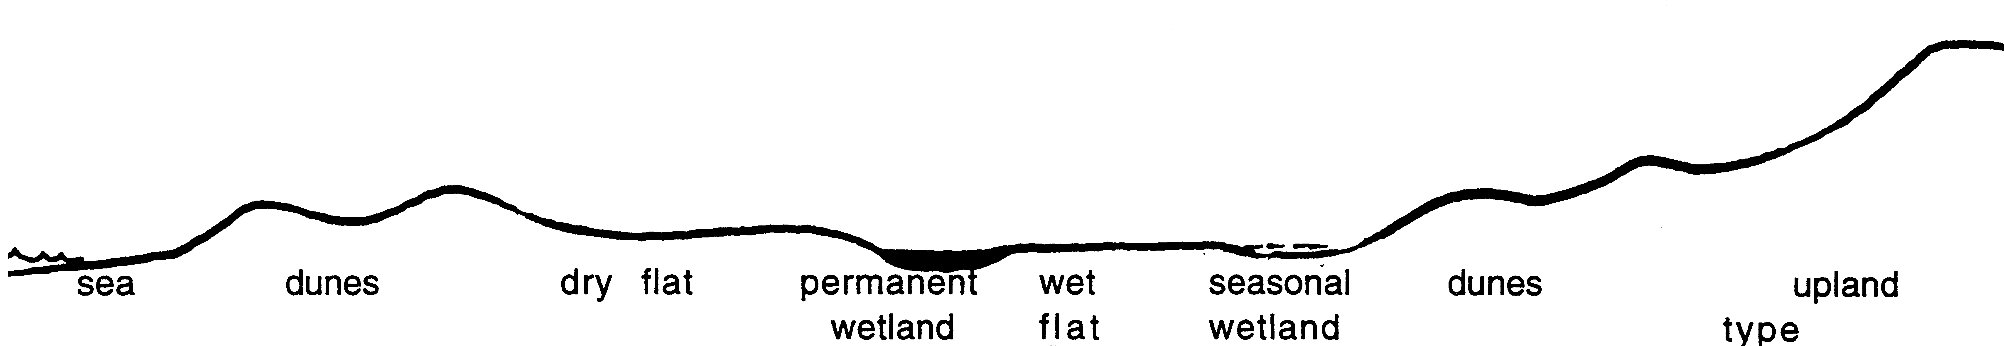
2. SITE DATA Circle the correct response.
Slope: flat gentle steep |  | Aspect: N NE E SE S SW W NW na
Surface Soil: sand, loamy sand, sandy loam, loam, clay, gravel/laterite Colour
Exposed rock: type |  | % surface
Sub-surface Soil: sand, loamy sand, sandy loam, loam, clay, gravel/laterite Colour
Rock: type |  | depth to rock
Drainage: well mod poor | depth water cm |  | Wet: all year winter/spring na
Litter: % cover |  | Bare Ground % cover
Depth cm

BUSHLAND PLANT SURVEY RECORDING SHEET 2 – use pencil only
 |  |  |  |  |  |  |  |  |  | From ‘Bushland Plant Survey’ written by B. Keighery (1994) and published by the Wildflower Society of WA (Inc.), PO Box 64 Nedlands WA 6008.
3. VEGETATION STRUCTURE AND COVER
For each layer record – appropriate growth form, cover class (see below) and dominant species in their order of dominance, up to a maximum of 3 species. If more than 3 species are obviously dominant record as many as appropriate to describe each layer. For NVIS record max. height of layer & % crown cover to nearest 5%.
Cover Class 2 – 10% 10 – 30% 30 – 70% over 70%
TREES MALLEES
 | over 30m |  |  |  | 10 – 30m |  |  |  |  |  |  | under 10m |  |  |  | over 8m |  |  |  |  |  | under 8m
GROWTH  FORM | 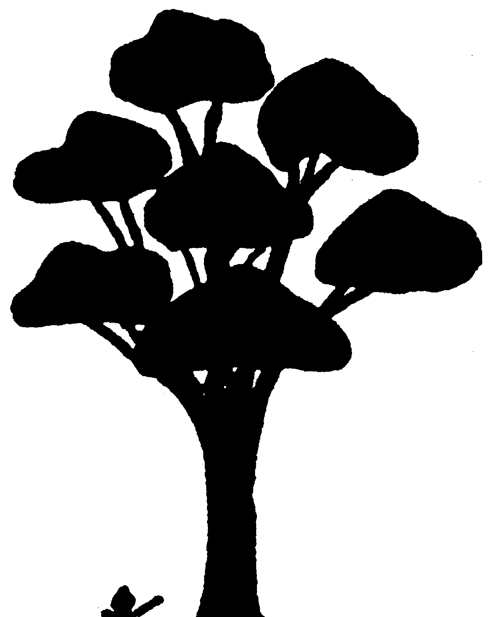 |  |  |  | 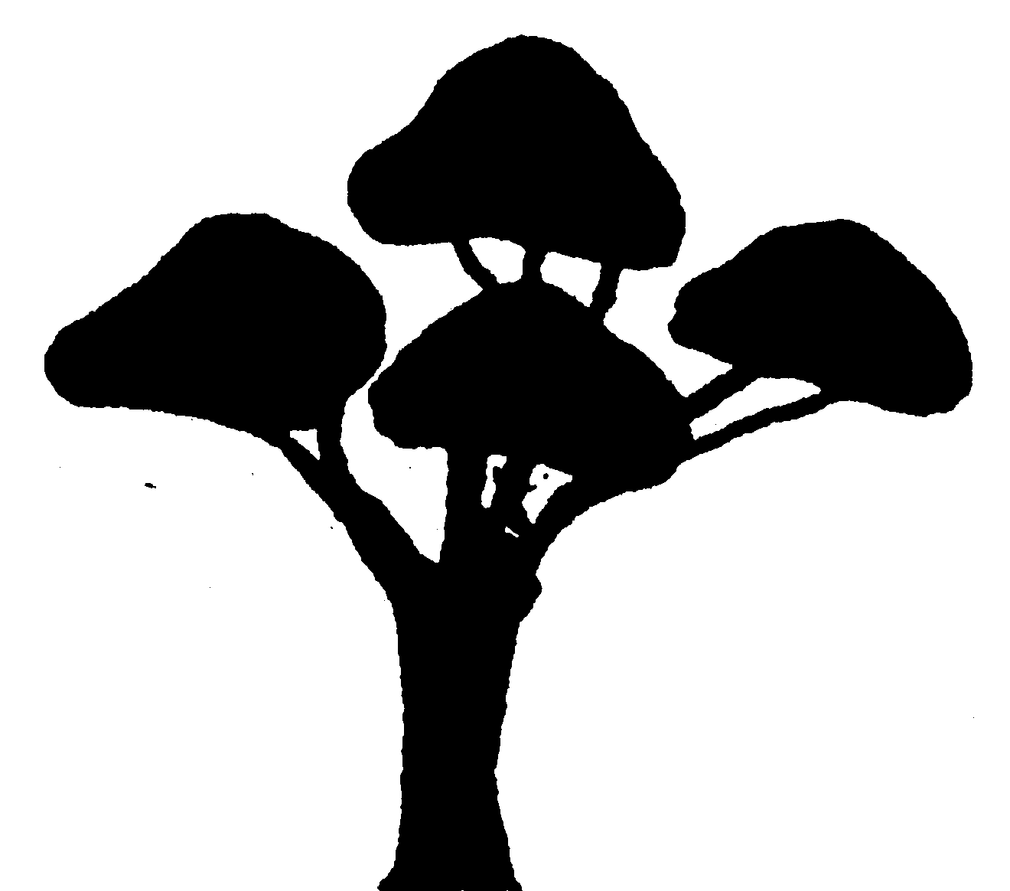 |  |  |  |  |  |  |  |  |  |  |  |  |  |  |  |  | 30m  10m
COVER  CLASS (%) |  |  |  | # |  |  |  |  |  |  | # |  |  |  | # |  |  |  |  |  | # |  | #
HEIGHT & CROWN COVER (NVIS)
DOMINANT SPECIES
SHRUBS SHRUBS
 | over 2m |  |  |  |  |  |  |  | 2m – 1m |  |  |  |  |  |  |  |  | under 1m
GROWTH  FORM |  |  |  |  |  |  |  |  | 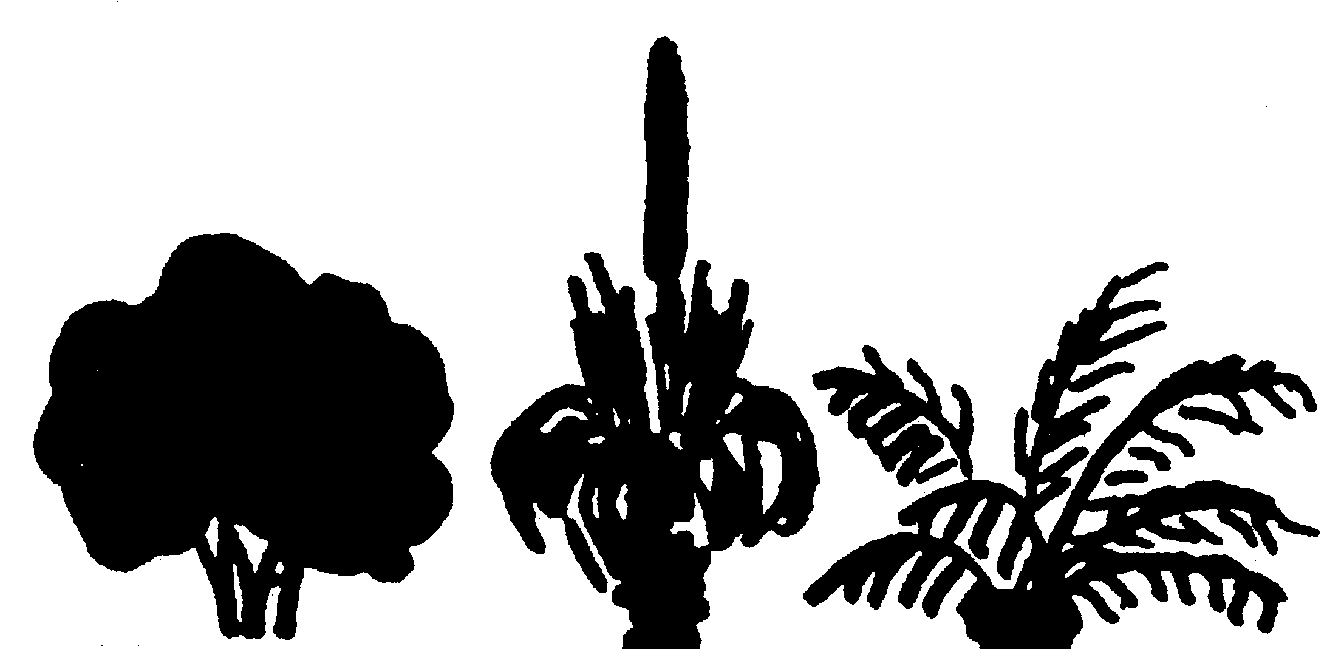 |  |  |  |  |  |  |  |  | 2m  1m
COVER  CLASS (%) |  |  |  |  |  |  |  | # |  |  |  |  |  |  |  |  | # |  |  |  |  |  | #
HEIGHT & CROWN COVER (NVIS)
DOMINANT SPECIES
GRASSES |  |  |  |  |  |  | HERBS |  |  |  |  |  |  | SEDGES |  |  |  |  |  | OTHER (eg. ferns)
GROWTH  FORM | 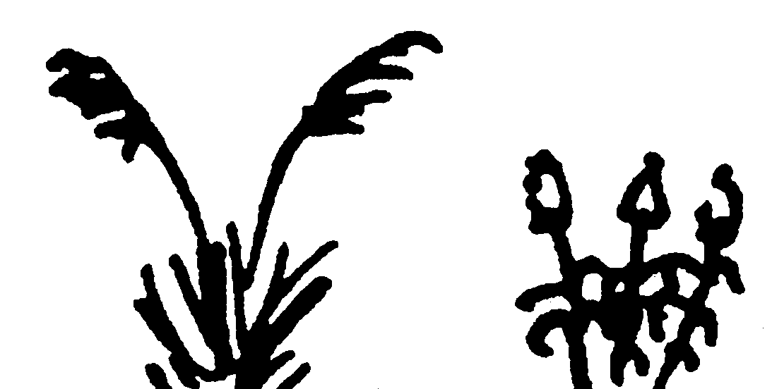 |  |  |  |  |  |  |  |  |  |  |  |  |  |  |  |  |  |  | 1m
COVER  CLASS (%) |  |  |  |  |  | # |  |  |  |  |  |  | # |  |  |  |  |  | # |  |  |  | #
HEIGHT & CROWN COVER (NVIS)
DOMINANT SPECIES
4. VEGETATION CONDITION (see Keighery 1994 in Appendix 4 of PBP NAIA Templates)
1 ‘PRISTINE’ |  |  | COMMENTS (give reasoning for choice)
2 EXCELLENT
3 VERY GOOD
4 GOOD
5 DEGRADED

BUSHLAND PLANT SURVEY RECORDING SHEET 3 – use pencil only
5. SPECIES PRESCENCE Label each plant with plant’s number, site code, date and plant’s name or working name if required |  |  |  |  |  |  |  |  |  |  | From ‘Bushland Plant Survey’ written by B. Keighery (1994) and published by the Wildflower Society of WA (Inc.), PO Box 64 Nedlands WA 6008.
Database SITE No | Record on sheet | - Column 1 |  |  |  | plant name
Date |  | - Column 2 |  |  |  | plant number
 |  | - Column 3 |  |  |  | identification checked - √ when checked
TREES |  |  | No | ID | SHRUBS (cont.) |  |  | No | ID | HERBS (cont.) |  | No | ID
MALLEES
 |  |  |  |  | GRASSES
SHRUBS
 |  |  |  |  |  |  |  |  |  | SEDGES
 |  |  |  |  | HERBS
Icon Flora Species (Note on list above if present) |  |  |  |  |  |  | Icon Community (tick if an icon community)
Description of Structural Plant Community No. __ (see Appendix 2 of PBP NAIA Templates)

A comparison of the Keighery (1994) and Kaesehagen (1994) vegetation condition scales for natural area assessment.
Keighery Condition Scale  (Keighery 1994) | Kaesehagen Condition Scale  (Kaesehagen 1994)
Pristine
Pristine or nearly so, no obvious signs of disturbance
Excellent  Vegetation structure intact; disturbance affecting individual species; weeds are non-aggressive species | Very good to excellent  - 80% to 100% native flora composition  - Vegetation structure intact or nearly so  - Cover/abundance of weeds <5%  - No or minimal signs of disturbance
Very good  Vegetation structure altered; obvious signs of disturbance  For example, disturbance to vegetation structure caused by repeated fires; the presence of some more aggressive weeds; dieback; logging; grazing | Fair to good  - 50% to 80% native flora composition  - Vegetation structure modified or nearly so  - Cover/abundance of weeds 5% to 20%, any number of individuals  - Minor signs of disturbance
Good
Vegetation structure significantly altered by very obvious signs of multiple disturbances. Retains basic vegetation structure or ability to regenerate it.
For example, disturbance to vegetation structure caused by very frequent fires; the presence of some very aggressive weeds at high density; partial clearing; dieback; grazing.

Degraded  Basic vegetation structure severely impacted by disturbance. Scope for regeneration but not to a state approaching good condition without intensive management.  For example, disturbance to vegetation structure caused by very frequent fires; the presence of very aggressive weeds; partial clearing; dieback; grazing | Poor  - 20% to 50% native flora composition  - Vegetation structure completely modified or nearly so  - Cover/abundance of weeds 20% to 60%, any number of individuals  - Disturbance incidence high
Completely Degraded  The structure of the vegetation is no longer intact and the area is completely or almost completely without native species.  These areas are often described as ‘parkland cleared’ with the flora comprising weed or crop species with isolated native trees or shrubs. | Very Poor  - 0% to 20% Native flora composition  - Vegetation structure disappeared  - Cover/abundance of weeds 60% to 100%, any number of individuals  - Disturbance incidence very high

Indicator Species

Some common plants that are susceptible to Phytophthora cinnamomi are used as Phytophthora Dieback indicator species. For example, common indicator species in the northern jarrah forest include Banksia grandis (bull banksia), Patersonia spp (purple flag and yellow flag), Persoonia longifolia (snottygobble), and Xanthorrhoea preissii (balga or grass tree). If plants of these indicator species are selectively dead or dying amongst otherwise healthy bushland plants then it is safe to assume that this indicates the Phytophthora Dieback in the areas until confirmed otherwise by registered interpreters.
Refer to the current table of dieback indicator species posted in the Dieback Working Group website.

WA Dieback Map

Dieback Information Delivery Management System (DIDMS) supported by Project Dieback and South Coast NRM.
For detailed plant disease information, land managers can register for a free DIDMS user account. Public version of dieback mapping information provides a basic viewing platform of generic plant disease information.
Go to Dieback Public Map - Project Dieback

Appendix 6: List of datasets required to support desktop assessment.

Visit www.data.wa.gov.au to identify and download spatial data. All datasets are subject to varying licencing requirements.

Name | Data Custodian
Aboriginal Heritage | DPLH - Go to Aboriginal Heritage Inquiry System
Aerial Photography | Landgate
ARVS Vegetation units (Albany Regional Vegetation Survey) | DBCA
Bushforever 2020 | DPLH
Cadastre | Landgate
Carnabys Cockatoo Habitat (Breeding, Roosting and Feeding) | DBCA
DBCA Lands of Interest | DBCA
DBCA Legislated lands and waters | DBCA
Dieback risk Area | South Coast NRM - WA Dieback map - Dieback Information Delivery Management System (DIDMS) on-line platform
EPA Policy Area - Bioplan Regionally Significant Areas 2010 | DWER
FMD 100 Year ARI Floodplain Area | DWER
Geomorphic Wetlands , Swan Coastal Plain | DBCA
Geomorphic Wetlands Cervantes South | DBCA
Geomorphic Wetlands Cervantes Coastal | DBCA
Geomorphic Wetlands Cervantes, Eneabba | DBCA
Geomorphic wetlands Darkan Duranillin | DBCA
Geomorphic wetlands Leeuwin Naturaliste & Donnybrook to Nannup -unreviewed | DBCA
Geomorphic wetlands South West unreviewed | DBCA
Geomorphic Wetlands Wheatbelt - Stage 1 | DBCA
Geomorphic Wetlands, Augusta to Walpole | DBCA
Geomorphic wetlands, Manjimup to Northcliffe - unreviewed | DBCA
Geraldton Regional Flora and Vegetation Survey Plant Communities | DLPH
Hydrography, linear | Landgate
Important Wetlands Australia | DBCA
Local Planning Scheme Zones & Reserves | DPLH
Native Vegetation Extent | DPIRD
Native vegetation extent by Beard Veg Associations | WALGA
Native vegetation extent by vegetation complexes | WALGA
Native vegetation extent - North Batavia coast flora and vegetation survey Plant Communities | DBCA
Perth Regional Ecological Linkages | WALGA
Potential Quenda habitat | DBCA
Pre-European Vegetation (Beard mapping) | DPIRD
Public Drinking Water Source Area (PDWSAs) | DWER
RAMSAR, Wetlands | DBCA
Regional Parks | DBCA
Region Schemes-zones & reserves | DPLH
Reserves | Landgate
Soil Landscape Mapping - best Available | DPIRD
South Coast Macro-corridors, including Zones & Names | DBCA
South Coast Significant Wetlands | DBCA
South West Regional Ecological Linkages - Axis lines | WALGA
Swan Canning Rivers Development Control Area | DBCA
Swan Coastal Plain Remnant Vegetation (2000-2020) | DPIRD
Threatened and Priority flora | DBCA
Threatened Ecological Communities (polygons) | DBCA
Threatened Ecological Communities Buffered | DBCA
Threatened and Priority Fauna | DBCA
Vegetation Complexes of the South West Forested Regions (Jarrah Forest) | DBCA
Vegetation Complexes-Swan Coastal Plain | DBCA
WA Herbarium Records | DBCA
Walpole Wilderness Peat Wetlands - unreviewed | DBCA
Western Ringtailed Possum Areas | DBCA
Wheatbelt Wetlands Stage 1 | DBCA

Appendix 7: Percentage ground cover guide.

Source: McNaught, L., Thackway, R., Brown, L. and Parsons, M. A field manual for surveying and mapping nationally significant weeds. 2nd Edition, Bureau of Rural Sciences, Canberra.

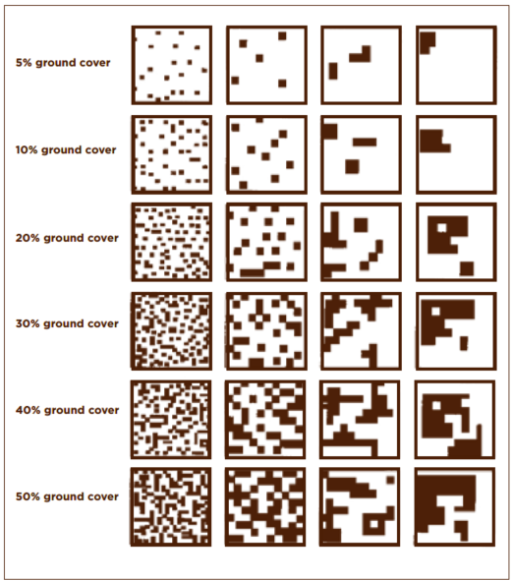

Appendix 8: Viability Estimate Guide
VIABILITY ESTIMATE
Viability Factor | Information Source | Instruction and Explanation
Size | Desktop Assessment or Map 2 | Refer to the Desktop Assessment for the area calculation. An exception to using this figure would be if boundaries had been modified during the Field Assessment A (Map 2) If so, does it change the outer boundaries of the site or merely internal boundaries? Circle the appropriate score.
Shape | Map 2 | Approximately describe the shape of the reserve from the options listed. Circle the appropriate score.
Perimeter to area ratio | Desktop Assessment or Map 2 | Use the calculation from the Desktop Assessment. An exception to using this figure would be if boundaries had been modified during the Field Assessment A (Map 2) Where necessary, recalculate the ratio by dividing the perimeter in metres by the area in metres squared (1 hectare (ha) = 10 000 m²). Circle the appropriate score.
Vegetation condition | Field Assessment A  AND  Appendix 4 of the NAIA templates | Note that this field is based on the Keighery (1994) or Kaesehagen (1995) vegetation condition scales (see Appendix 4 of the templates). Page 17 of the NAIA templates uses the Keighery (1994) condition scale, but if Kaesehagen (1995) is used, use the multipliers given in the table below.  Each category of vegetation condition has been assigned a numerical value. Very few natural areas will be 100% in one vegetation condition. Use the table for vegetation condition on page 9 of Field Assessment A to calculate the score. Multiply the value assigned to each category of vegetation condition by the percentage it takes up of the natural area and sum these to reach the calculated score. Enter the calculated score in the final column. Scores will range between 0 and 10.  For example:  A reserve has been assessed as:  95% Excellent, 5% Degraded (using the Keighery 1994 scale)  “Excellent” has a multiplier of 8x  “Degraded” has a multiplier of 2x  (0.95 x 8) + (0.05 x 2) = 7.70 (score can have up to 2 decimal places)
 |  | Keighery Condition Scale | Multiplier (for Viability Estimate) | Kaesehagen Condition Scale | Multiplier (for Viability Estimate)
 |  | Pristine | 10x | Very Good to Excellent | 8x
 |  | Excellent | 8x
 |  | Very Good | 6x | Fair to Good | 5x
 |  | Good | 4x
 |  | Degraded | 2x | Poor | 2x
 |  | Completely Degraded | 0x | Very Poor | 0x

Criteria / Viability Factor | Information Source | Instruction and Explanation
Connectivity | Desktop  Assessment  AND  Reserves  AND  Local Government Local Planning Scheme (LPS) | The Desktop Assessment identifies natural areas that form part of a Regional Ecological Linkage.  You will need to assess the protection status of all natural areas over 4 hectares that are within 500m of site under assessment. By definition protection is conferred either through the vesting purpose of Crown Reserves, zonings under LPS, and voluntary conservation covenants. For relevant datasets see Appendix 6. Use the ‘measure’ tool in GIS to identify other natural areas within 500m and access information on those sites for:  - area (ha);  - Bush Forever;  - Reserve vesting purpose combined with reference to the LPS if it includes conservation provisions; and  - Knowledge of any private areas under conservation covenants.  Circle the appropriate ranking.
TOTAL SCORE |  | Sum the individual rankings to calculate the total score. Viability Estimate scores will range between 3.25 and 27.5.

Acknowledgements

Natural Area Initial Assessment Templates were developed via Perth Biodiversity Project in 2003-2004 and published in the Local Government Biodiversity Planning Guidelines for the Perth Metropolitan Region (Del Marco et al, 2004). In 2006, these Templates were adapted for the South West Biodiversity Project area.
The Perth Biodiversity Project and the South West Biodiversity Project were Local Government initiatives delivered through the Western Australian Local Government Association (WALGA), with funding support from the Australian Government’s Natural Heritage Trust (2001-2009), National Action Plan for Salinity and Water Quality (2006-2009) via the Swan Catchment Council and the South West Catchment Council.
This Project is supported by funding from the Western Australian Government’s State NRM Program
This version of the Templates was created via WALGA’s Local Biodiversity and Native Vegetation Management Project (2023-2024).

Smaller thresholds can be used in areas with high levels of historical clearing
Only applicable to areas with vegetation type mapping at higher levels than vegetation complexes such as vegetation mapping units in the Albany Regional Vegetation Survey (2010).
For example, a Certificate in Bush Regeneration (Certificate II and III in Conservation and Land Management) (minimum of six month study)
for example, a Degree or Diploma in Environmental Science or Biology (minimum of three years study)

