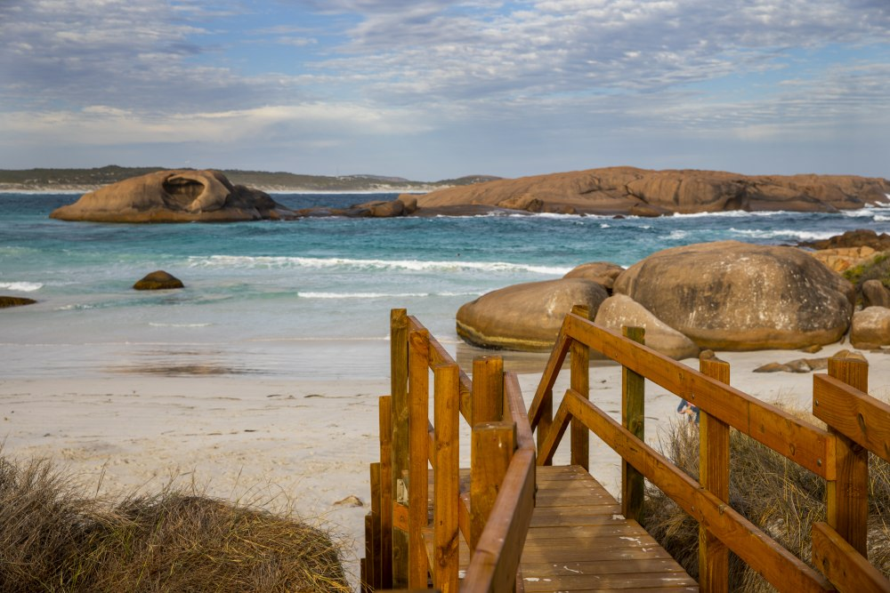
WALGA Climate Emergency Declaration Template
Image: Twilight Beach, Esperance (Source: WALGA)

Acknowledgement
The WA Local Government Association (WALGA) acknowledges the Traditional Owners of the land and pays respects to Elders past, present and emerging.

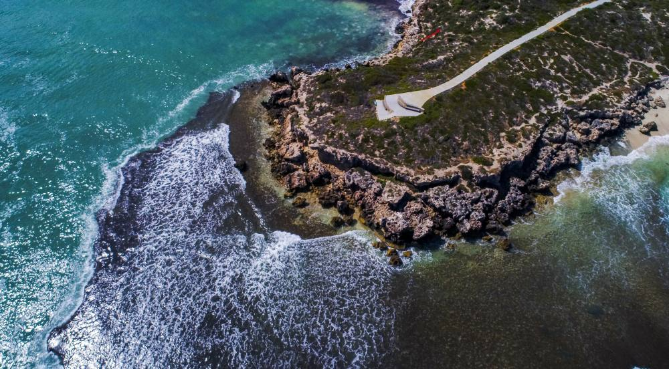
Image: Three Bays Walk, Coorow (Source: WALGA)

Table of Contents
Using this Climate Emergency Declaration Template 4
Background 7
What is the Climate Emergency? 7
What is a Climate Emergency Declaration? 7
Declaration 8
Our Approach 9
Commitments 9
Signatures 10

Using this Climate Emergency Declaration Template
This Climate Emergency Declaration Template has been developed to assist Local Government to take action to manage the impacts of climate change (adaptation) and reduce greenhouse gas emissions (mitigation).
The template contains text in red that is intended to be edited by Local Governments to reflect their climate actions and commitments.
A Climate Change Declaration may be adopted by Local Governments who are committed to taking urgent climate action and allocate resources accordingly, to rapidly scale up their mitigation and adaptation actions.

This template is divided into four sections:
- Context
- A Declaration;
- The Adopted Approach;
- Commitments; and
- Signatures.

- Background

Background information defining the climate emergency and what it means to declare a climate emergency is provided.
- Declaration

A high level statement is provided and the Local Government is required to declare a climate emergency and a commitment to take urgent action to address climate change.
- Adopted Approach

The Local Government is required to select relevant activities and strategies from the provided list, or add their own, to demonstrate their current and completed actions to respond to climate change.
- Signatures

A space is provided for the signature of the Mayor/Shire President of the Local Government and demonstrates the support of the Council in declaring a Climate Emergency.

The Climate Emergency Declaration template begins on the next page.

Local Governments may choose to delete the following pages previous pages including:
- The WALGA Climate Emergency Declaration template cover page;
- The WALGA Acknowledgement of Country;
- Using this Climate Emergency Declaration template page.

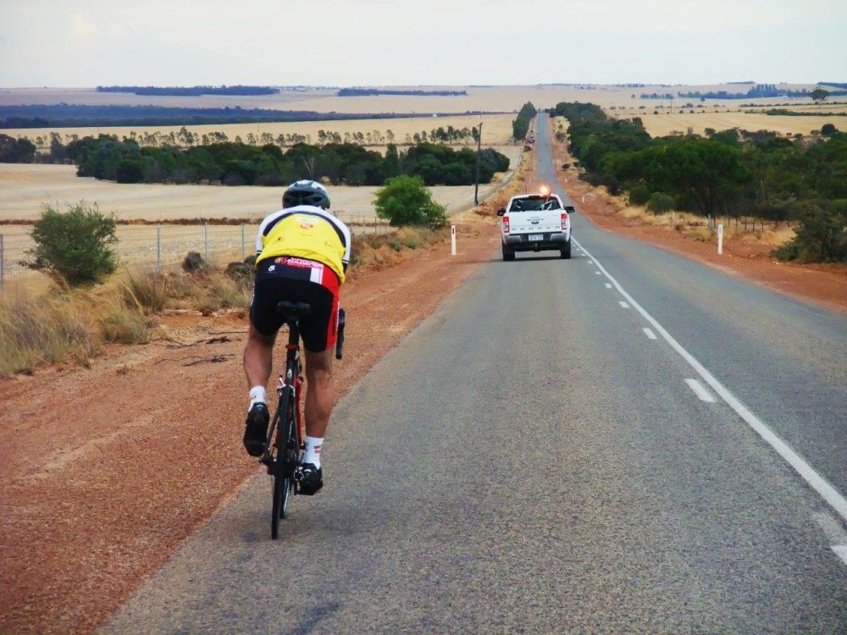
Shire/City/Town of [insert]
Climate Emergency Declaration
Image: Bike rider (Source: WALGA)

Background

What is the Climate Emergency?

The climate emergency is defined as ‘dangerous changes to the world’s climate caused by human activity’ that require immediate action ‘to protect the planet and to ensure a safe future for all life on earth’ (City of Darebin 2016). To do this, the following measures are proposed:
- Stop producing greenhouse gases that are produced by coal, oil and gas; and
- Remove current greenhouse gases from the atmosphere.

In 2016, the City of Darebin in Victoria was the first government in the world to declare a climate emergency citing ‘the need for fast and coordinated action to address climate change’ (City of Darebin 2016). Since then the Climate Emergency movement has grown globally and around 100 Local Governments in Australia have declared a Climate Emergency (Climate Emergency Declaration 2021).

What is a Climate Emergency Declaration?

A Climate Emergency Declaration is a commitment to ‘mobilise society-wide resources at sufficient scale and speed to protect civilisation, the economy, people, species and ecosystems’ and to ‘fully restore a safe climate’ (Climate Emergency Declaration 2021). The emergency framing of climate change has been adopted to:
- Communicate the urgency and systems change needed; and
- To encourage citizens and politicians to work together for the common good, as they would in other emergency situations.

Declaration
The Shire/City/Town of [insert] declares a climate emergency. Climate change poses a significant threat to our community and the world at large. Our people, our environment and our economy will be severely impacted without significant change to the way we live.
By declaring a Climate Emergency, the Shire/City/Town of [insert] acknowledges that:
- Climate impacts are already causing serious loss of life and destroying vital ecosystems;
- Global average temperature, atmospheric greenhouse gases, and ocean acidity are already at dangerous levels;
- Wartime economic mobilisations have proven how quickly nations can restructure their economies when facing an extreme threat; and
- It is inexcusable to continue with climate-damaging policies that put us all in even greater peril. The Paris Agreement’s 1.5°C goal is not a safe goal.

International scientific consensus is that climate change is occurring, and it is driven by anthropogenic causes, with human activities having a profound impact on the concentration of greenhouse gas emissions since the start of the industrial revolution. The changing climate is having impacts on our environment, our infrastructure and assets, and our communities.
In Australia, the 2018 Bureau of Meteorology State of the Climate Report (CSIRO and Australian Government Bureau of Meteorology, 2018) found that the climate has warmed in both surface air temperature and surrounding sea surface temperature by around 1°C since 1910. As a result, Western Australia is expected to experience higher temperatures, sea level rise, less rainfall, and more extreme weather events. These changes have the potential to impact our environment, our assets and infrastructure, and the health, safety and wellbeing of our people.
All tiers of government, Federal, State and Local, have a duty to respond to the negative impacts of climate change. Local Governments play a central role in driving change by promoting and facilitating more sustainable communities. As such, over 1,860 Local Governments worldwide have declared a climate emergency [Note: Local Governments should refer to the Climate Emergency Declaration website (https://climateemergencydeclaration.org) and update figure in text to reflect the latest available data prior to publishing Declaration].
The Shire/City/Town of [insert] recognises that urgent action is required and is committed to taking action to limit the climate crisis. We will work alongside our community, the State and Federal government, businesses and other actors to mitigate and respond to this climate emergency. We commit to minimising our greenhouse gas emissions and reducing vulnerability to the effects of climate change within our community.

Our Approach

We commit to developing policies/procedures/actions plans/frameworks/strategies to mitigate and respond to the climate emergency. We will regularly monitor and update these documents to ensure they remain relevant and current.
To date, the Shire/City/Town of [insert] has:
[Select from/add to the list below based on the existing strategies and/or work completed by the Shire/City/Town to respond to climate change]
- Developed an Emissions Reduction Plan
- Developed a Climate Change/Emissions Reduction/Sustainability Strategy
- Developed a Climate Change Action Plan/Corporate and/or Community Adaptation Action Plan/ Corporate and/or Community Mitigation Action Plan
- Completed a climate change risk assessment
- Adopted a renewable energy target
- Set waste, electricity, gas and fuel etc. targets
- Reduced emissions from electricity/fleet/street lighting etc. by X/XX%

Whilst we are proud of the work we have undertaken, we recognise that we need to take further action. We have recently developed and implemented [alternative text: are in the process of developing] our Corporate/Community/Adaptation/Mitigation Action Plans. These plans outline the actions that we will take to respond to the climate emergency, specifically our Mitigation Plan/s set/s out our approach to reducing greenhouse gas emissions and our Adaptation Plan/s Plan/s set/s out our approach to reducing community vulnerability and improving preparedness.
Please refer to the Shire/City/Town of [insert]’s Corporate/Community/Adaptation/Mitigation Action Plans for additional detail.

Commitments

The Shire/City/Town of [insert] commits from the date of signing to:
- Reach zero emissions as fast as humanly possible and rapidly scale up efforts to draw down excess greenhouse gases already in the atmosphere;
- Revisit Local Government climate change policies and strategies to ensure that action is being taken at the necessary scale and speed to meet climate emergency commitments;
- Mobilise government and community resources and funds that are not normally available; and
- Encourage all other governments around the world to take these actions.

Signatures
Signed:

Mayor/President - Shire/City/Town of [insert]
Date:

