Economic development strategy (template)

About the template

Purpose
WALGA commissioned this template to assist Councils across the State prepare robust Economic Development Strategies (EDSs).
The template includes a standard narrative structure. This addresses all facets of an EDS including understanding existing conditions, auditing strengths and weaknesses, establishing a vision and objectives and creating strategies and action plans to achieve Council’s goals.
The template is intended to be useful for the full spectrum of local governments in WA, ranging from very small rural and remote municipalities that have limited resources for planning through to metropolitan Councils that have dedicated teams for economic development. Users can follow the guidance that suits them best, with the template providing links and hints aligned to either ‘base model’ or more elaborate versions of EDSs.

Economic Development Framework
This template should be read in conjunction with the updated local government Economic Development Framework (EDF) document also commissioned by WALGA (include web link). The EDF defines ‘economic development’ and discusses the role of Councils in this endeavour versus those of other levels of government. It introduces various concepts of economic development that might frame the strategy building process in Councils, including ‘community wealth building’ and ‘planning to three horizons’. The EDF also provides an economic profile for each of WA’s regions. For a detailed overview of the scope of EDSs and the role Councils play in delivering functions to support economic development, please see the EDF document.

The overall EDS narrative
The template applies a seven-part narrative.
- About the Economic Development Strategy, outlining the purpose and scope of the strategy and explaining how it fits in with Council’s other plans and policies
- Profiling the economy, providing a snapshot of the structure and recent performance of the economy
- Forces shaping the economy, surveying the high level conditions such as technological and structural market shifts, and State and Commonwealth policy settings, within which the local economy must work
- Competitiveness and community wealth potential, auditing the strengths, weaknesses, opportunities and threats facing the local economy
- The ambition, describing Council’s vision and associated goals and objectives for the local economy
- Strategies to deliver the vision, setting out what needs to change if the adopted economic development goals and objectives are to be achieved
- The plan into action, breaking down the strategic responses to the vision into a schedule of time bounded actions, with resource requirements and assignment of lead, partnership and support roles.
This structure is not prescriptive. Councils may wish to develop their economic development story and calls to action in other ways. However, the seven part narrative presented in the template reflects a standard, widely practiced, approach to strategic planning.

Timeframes
The template anticipates that EDSs will generally have a 5 year time frame, but set within a longer term vision, perhaps stretching to 10 or 15 years.

Section 1: About the Economic Development Strategy
This section sets out the purpose, scope and timeline of the EDS and explains how it fits with other Council plans and policies. It describes how the EDS was compiled and how Council will monitor and refine the Strategy in the years ahead.

Overview

Content guide
Briefly describe the purpose of the Strategy in guiding Council’s role in economic development.
Identify key planning parameters such as the geographic scope of the Strategy, its timeline and whether it is focused on particular sectors or issues.
Provide a word and or diagrammatic depiction of how the EDS relates to the other plans, strategies and policies which the Council has or will develop in the future.

How the Strategy was prepared

Content guide
Describe how the EDS was developed. This should refer to the mandate from Council; that is, when and why was the EDS commissioned.
Give details of who was involved in the development of the Strategy and the process applied to generate this document. Refer to the community/stakeholder engagement process as well as the principal milestones from Council mandate to this product.
If the EDS is premised on an overarching philosophy or economic framing – such as ‘Circular Economy’, ‘Community Wealth Building’, ‘Triple Bottom Line’, ‘Competitive Advantage’ etc, introduce this here and explain the reasons for this choice. Discuss how this framing has shaped the general direction of the Strategy.
The EDS is required to align with Council’s Strategic Community Plan, which all local governments must produce under legislation.

Sources and tips
Economic Development Australia (EDA) provides an accredited training program which includes detailed course notes on different conceptual frameworks to guide economic development planning. https://www.edaustralia.com.au/training/professional-accreditation-stream/
Local Government Intelligence Unit (Australia) regularly publishes expert essays on local economic development https://lgiu.org/briefing/a-new-framework-for-economic-development-prioritising-people-place-and-planet/
Key references on Community Wealth Building include: Raghuram Rajan (2020) The Third Pillar - How Markets and the State Leave the Community Behind, Harper Collins; Shuman, M. H. (2001) Going Local: Creating Self-Reliant Communities in a Global Age, Routledge; CLES (2020) Own the future: a guide for new local economies, self-published.
https://www.harpercollins.com.au/9780008276300/the-third-pillar/
https://www.routledge.com/Going-Local-Creating-Self-Reliant-Communities-in-a-Global-Age/Shuman/p/book/9780415927680
https://cles.org.uk/blog/own-the-future-a-guide-for-new-local-economies/
Information on Strategic Community Plans and integrated planning and reporting can be found here:
https://www.dlgsc.wa.gov.au/local-government/strengthening-local-government/integrated-planning-and-reporting/strategic-community-plan
https://www.dlgsc.wa.gov.au/local-government/strengthening-local-government/integrated-planning-and-reporting

Implementation and monitoring

Content guide
Outline the governance, resourcing and partnership arrangements which Council has, or will, put in place to implement the Strategy. This might include an ongoing internal, external or mixed committee of experts, stakeholders and elected members to oversee the roll out of the action plan in Section 7.
Describe how the impact of Strategy will be evaluated. This could include brief reference to Key Performance Indicators, noting that more detailed discussion of these metrics may be found in Section 7.
If relevant, state how the Strategy will be refreshed during the implementation phase, and when it will be comprehensively reviewed.

Section 2: Economic Profile
This section of the EDS provides an overview of the current structure and recent performance of the LGA economy.

Content guide
Provide a full description of the economy and demography of the municipality.
If possible, provide and interpret time series data on key measures of economic performance, including comparisons with State and national averages. A ten year time frame is usually adequate for this purpose.
A basic EDS should address at least the following economic performance measures; population change; population age composition, number of people employed and hours worked; employment by sector; number of people unemployed.
Appendix A steps out how to calculate and display data for these ‘basic’ economic performance measures.
If resources allow, the profiling of the local economy should also address:
•Female and male participation rates (versus State and comparable regions)
•Household income and trend (versus State and comparable regions)
•Skills profile and trend (versus State and comparable regions)
•Gross Value Added status and trend (versus State and comparable regions)
•Principal exports (sales to customers outside of the LGA, whether these are within WA, interstate or overseas, and principal imports
•Escape expenditure by households (retail spending that ‘leaks’ to providers outside the LGA)
•Principal industries / specialisations (identified using Location Quotient analysis – see Appendix A)
•Local anchor institutions, including total employment and annual spending
•Geography of the economy including areas of socio-economic advantage and disadvantage
•Major infrastructure assets that underpin economic performance, including key transport linkages
•Composition of businesses including their risk of financial failure.

Section 3: Factors shaping the economy
This section looks at the state, national and global environment within which the LGA economy is operating. It canvasses the technological, structural and trade factors which are largely outside the control of local parties, but which will have a profound impact on the direction and trajectory of the local economy.
Content guide
Identify and discuss the external trends, forces and policy settings which will shape the potential futures open to the local economy.
Discussion of these external factors could be organized on three tier basis aligned to global/international, national and state influences. Depending on the LGA in question, potentially relevant topics include:
Global/international
•Climate change and policy responses by governments (for example, the US Inflation Reduction Act, 2022)
•Patterns of outsourcing and on-shoring under the influence of supply chain unbundling, globalization and fragmentation of trading blocs
•Impacts of technology, including sustained working from home, influence of AI in business processes and use of robotics in production
National
•Demographic trends, especially ageing, increasing dependency rates and shifts in internal migration
•Forces shaping the Commonwealth budget including growth in outlays on health and NDIS
•Impact of trade deals already negotiated by the Commonwealth and in the offing
•Developments in Commonwealth industry policy linked to climate change mitigation and defence amongst other factors
•Projected performance of the national economy over the planning period for the EDS
•Policy and engagement with First Nations on recognition and economic development
State
•WA Government’s vision and policy settings for metro, regional, rural and remote parts of the State
•Key State Government infrastructure projects
•WA Government’s policy settings for, and investment in, education, training and skills development
•WA Government’s industry policy and regional priorities
•State Government policy and engagement with First Nations on recognition and economic development
•WA Government policy on resource royalty distribution
Distill the implications of these wider influences for the local economy. For example, will the LGA have to contend with the closure of a major employer or decline of a key industry? Are there emerging industries that align with the competitive and comparative advantages of the local economy?

Sources and tips
Global/international resources
The International Monetary Fund publishes a number of documents outlining key global and regional economic trends. These include:
World Economic Outlook - A Survey by the IMF, usually published twice a year. It presents analyses of global economic developments during the near and medium term and addresses topics of pressing interest. (https://www.imf.org/en/Publications/WEO)
Regional Economic Outlook (Asia and Pacific) – These reports discuss recent economic developments and prospects for countries in select regions. They address regional policy developments and challenges, and provide country-specific data and analysis, including through analytical pieces on issues of interest to a particular region. (https://www.imf.org/en/Publications/REO)
National
The Commonwealth Government’s regular ‘Intergenerational Reports’, published by the Treasury, provide a good overview of long term economic and population projections, as well as the drivers of productivity (https://treasury.gov.au/sites/default/files/2021-06/p2021_182464.pdf )
Course notes commissioned by Economic Development Australia (EDA) for its accredited training program include discussion of macro factors impacting local economies including ‘unbundling of value chains’ and the rapid rise of e-commerce. (https://www.edaustralia.com.au/training/professional-accreditation-stream/)
ABS National Accounts are quarterly estimates of key economic flows in Australia, including GDP, consumption, investment, income and saving. (https://www.abs.gov.au/statistics/economy/national-accounts/australian-national-accounts-national-income-expenditure-and-product
The IMF has a dashboard displaying key economic indicators for the Australian Economy, including population trends and forecasts, GDP and unemployment rates. (https://www.imf.org/en/Countries/AUS)
State
The Western Australian Government produces monthly Economic Profile and Trade Profile documents. The Economic profile provides information on key economic trends for that state, as well as by regions. The Trade profile outlines market outlooks and key exports and trading partners. (https://www.wa.gov.au/government/publications/western-australias-economy-and-international-trade)
The Western Australian Treasury Corporation published an ‘Economic Strengths’ resource providing information and data on economic resilience, the housing market, energy security, exports and trade profiles. (https://www.watc.wa.gov.au/western-australia/wa-s-economic-strengths/)
The Western Australian State Budget provides key insights into the WA Government’s policy priorities. The budget papers outline the economic and fiscal outlook for the state as well as key initiatives and investment (https://www.ourstatebudget.wa.gov.au/). The Western Australian State Budget also provides regional snapshot documents that outline planned investment and spending by the State Government at the regional level. (https://www.ourstatebudget.wa.gov.au/regions.html)

Section 4: Competitiveness and community wealth potential
This section appraises how well placed the LGA economy is to respond to challenges and opportunities that are likely to confront it over the planning period. It applies a three pillar framework to uncover key strengths and weaknesses which need to be addressed in the EDS.
Content guide
Present a strengths, weaknesses, opportunities and threats (SWOT) analysis for the LGA economy.
In developing the SWOT analysis, users could audit the economy’s prospects of
•boosting inter-regional exports and other injections of income, and
•containing leakages of income from the LGA
by reference to three categories of ‘prosperity enablers’ relating to
•business,
•government, and
•community.
This is shown below and is derived, in part, from Raghuram Rajan (2020) The Third Pillar - How Markets and the State Leave the Community Behind, Harper Collins; Shuman.
An objective for good local economic performance is to maximise export income and the associated employment, while also minimising income leakages through imports. ‘Exports’ here refers to what businesses and organisations in the LGA sell to customers located outside of the municipality whether they be in elsewhere in WA, in other States and Territories or overseas. Export earners can include farming, mining and manufacturing enterprises that sell physical products to external customers. They can also be tourism businesses that provide accommodation, hospitality, transport, sightseeing and related services to external customers. Institutions and agencies like hospitals, universities and major schools can also act as exporters by bringing visitors and their associated spending into the LGA.
Export earners will typically be supported by local suppliers and workers. When their export sales increase a flow on impact, known as a multiplier effect, will be felt within their supply chains in the form of additional sales and employment.
A strong local economy needs export earners to underpin employment and investment. Their local multiplier impacts can be diluted if they source inputs from suppliers outside of the LGA or region. Similarly, local multiplier effects will be diluted if consumers import goods and services, by shopping outside of the LGA or online, or by choosing to work or pursue leisure outside the local area.
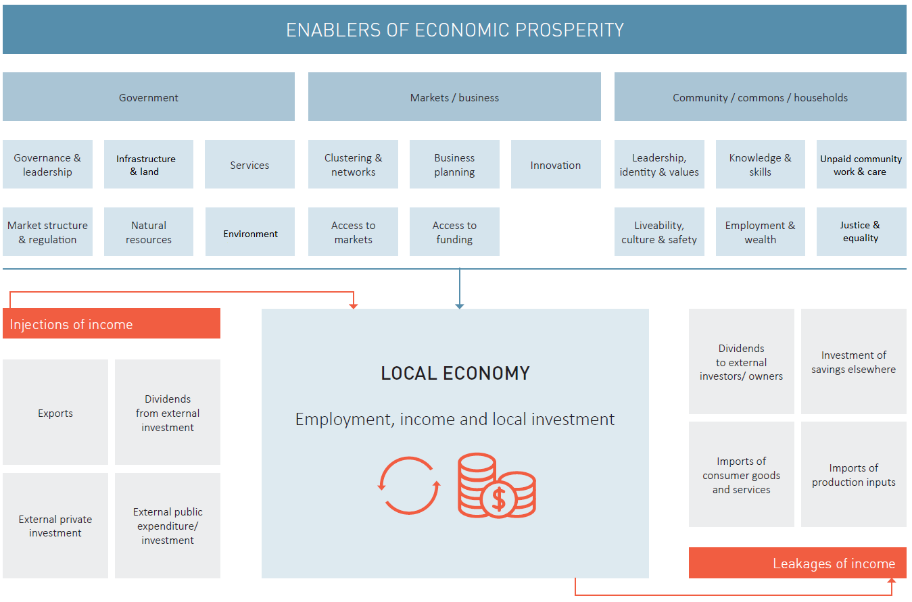

Sources and tips
The principal sources of export income to a municipality can be identified by:
Location Quotient analysis as outlined in the previous section – those industries with LQs well above 1.0 will likely be exporters, and / or
Input Output analysis, applied via a proprietary model (there are several commercial providers of these models in the market).
Input Output analysis can also be used to identify the principal leakages of income from the LGA or relevant region.
Issues to assess under each of the ‘enablers’ shown in the diagram include:
Government
Governance & leadership
•Clarity of strategic direction coming from State and Commonwealth Governments and what this means for the LGA
Infrastructure & land
•Adequacy of employment land stocks
•Availability of infrastructure to support development of employment land and establishment of key industries
•Land fragmentation, land withholding and other ‘market failures’ which may be impeding development of employment areas
•Quality and reliability of basic infrastructure – water, power, sewer, broadband
Government services to support business and economic development
•Effectiveness of local Commonwealth funded employment agencies
•Effectiveness of State Government business support services
Market structure & regulation
•Effectiveness or otherwise of town planning controls in supporting economic development
•Impact of liquor licensing, gambling licensing and other regulations on economic performance.
Natural resources
•Availability of natural resources (soils, minerals, water, forests, fisheries etc.) which impact on economic development
•Arrangements for First Nation stewardship of these resources
•Clarity of policy regarding conservation of natural resources
Environment
•Health of local ecosystems and threats to their sustainability
•Climate change and other environmental hazards potentially impacting the local economy (flooding, fire, rainfall reliability etc)
Markets / business
Clustering & networks
•Existence of established business clusters which improve the competitiveness of constituent firms
•Latent clusters and networks that could be activated with appropriate policies
•Links to clusters and networks in other regions
Business planning
•Evidence that businesses in key export sectors for the local economy are well managed (or otherwise) – a number of commercial providers publish analyses of official data on credit risk by business type by region (see for example https://svpartners.com.au/resource-centre/commercial-risk-outlook-report/ )
•Availability of resources to support good strategic management of local firms
Innovation
•Presence or absence of infrastructure and programs to support enterprise formation and innovation (e.g., incubators, business angels etc)
•Availability or otherwise of advanced business services (patent attorneys, finance brokers, engineers and designers) to support innovation
Access to markets
•Transport, IT and other infrastructure gaps that may impede access to inter-regional and international export markets
Access to funding
•Availability or otherwise of local banks and finance brokers to support business expansion, recognizing that existing businesses are likely to be the greatest single source of new investment into the LGA economy.
Community / commons / households
Leadership, identity & values
•Availability of local leaders with a clear vision for the LGA economy
•Extent of social capital / cohesion to support an EDS with ambition
•Presence of anchor institutions willing to subscribe to and invest in Community Wealth Building
Livability, culture & safety
•Availability of affordable housing
•Quality of living environments, including access to jobs and opportunities
•Presence or otherwise of a distinctive culture to enrich local living and attract tourists
Knowledge & skills
•Presence of underutilized or dormant skills in the local population
•Availability of mentoring opportunities for local businesses
Unpaid work
•Extent and sustainability of unpaid work in child care and local service agencies which directly and indirectly support economic development
Employment & wealth
•Income and wealth endowment of the local population and the implications for resilience in the face of economic downturns and disasters
Justice & equality
•Actual or potential co-stewardship of the local economy with First Nations people
•Presence or otherwise of concentrations of disadvantage and inter-generational exclusion

Section 5: The ambition
This section puts forward a vision and a set of goals and objectives for the ongoing development of the LGA’s economy, based on the competitiveness audit and the views of stakeholders.
Content guide
A manageable number of goals relating to discrete aspects of economic development is required as well as an overarching vision
The goals should be accompanied by objectives and targets.
The EDS may have a five or ten year time horizon, but it should be clear on what the long term outcome/s are that they are working towards
Framing the vision
Ideally, the vision should be a short sharp statement that evocatively conveys how the LGA will change over the near and long term under the influence of the EDS. It should be framed and worded to have a galvanizing effect on all stakeholders.
The overarching vision should convey the current and prospective strengths of the local economy, what the Council wants its economy to be known for and, if relevant, the philosophy underpinning the strategy (community wealth building, circular economy etc.).
What to consider when developing goals
The goals accompanying the vision should unpack the vision and set out what the strategy hopes to achieve.
The goals and objectives should be ambitious but realistic. They should reflect an understanding of the economy gained through statistical profiling, considering the external factors shaping the economy and the SWOT analysis as described above.
Goals and objectives should focus on reinforcing and building on the strengths of the economy, while also mitigating any identified weaknesses.
Goals and objectives should be specific and measurable as far as possible.

Sources and tips
The following illustrates a common way of articulating goals, objectives and targets.
Goal – Economic transformation
The LGA community will strive for economic transformation developing an innovative, creative, prosperous and sustainable local economy
10 year target: The LGA will move into the top half of State LGAs on GRP per capita by 2033
Goal – An open and dynamic economy
The Council and the community will be welcoming and supportive of new ideas, businesses, and residents. The LGA will be well connected to regional, national and international markets physically and digitally.
10 year target: the number of locally owned SMEs with a turnover over $n,000 will increase from x,000 to y,400 (at n% p.a.), and annual inward investment aligning with the objectives of the strategy will increase year-on-year
Goal – Economic diversification
The economy of the LGA will support a diverse range of local businesses and good employment opportunities for all
10 year target: The share of jobs that are full-time and provide above-average incomes against national benchmarks will increase year-on-year, and the number of towns/districts in the 20% most socio-economic disadvantaged in the State (as measured by ABS’s SEIFA index) will fall from x out of y areas in the LGA at present to only 10
Goal – New and expanded exports
The LGA will foster entrepreneurship and innovation in new and existing industries creating additional export products and services to inject new income into the local economy
10 year target: Exports increases from $x billion per annum to $y billion (at n% p.a.)
Goal – Community wealth building
Economic transformation will be achieved by community, government and business stakeholders working together to drive economic development. The Strategy will tie in with other strategies, including those focusing on health and well-being, the environment, industry and the arts, in a reinforcing way.
10 year target: The level of supply chain self-containment in the LGA economy will increase from n% of all inputs to y%
Goal – Ecological sustainability
The LGA will focus on developing a more contemporary economy with sustainability at its heart. Economic growth will be climate-resilient, leverage and regenerate natural assets, and the transition to a low-carbon and circular economy will create local business and employment opportunities
10 year target: The LGA will grow the number of businesses participating in the circular economy from x to y. The volume of organic waste to landfill will reduce by 90%. There will be an annual decline in municipal greenhouse gas emissions per dollar of GRP

Many Councils seek to reconcile their economic development goals and objectives with the UN Sustainable Development Goals. (https://sdgs.un.org/goals )
Further examples of approaches to specifying goals/objectives are provided in Appendix B.

Section 6: Strategies to deliver the vision
This section identifies what needs to change and what needs to be maintained if the LGA economy is to see improved employment and business outcomes in line with the vision and goals established earlier. This change and continuity agenda is expressed in a strategic direction for each economic development goal in turn.
Content guide
Strategies need to be developed with the specific purpose of meeting the goals and targets identified in Section 5.
Typically, strategies are aligned to each goal.
Alternatively, strategies may address themes or focus areas which will have been identified during the formulation of the EDS. These thematic strategies would be expected to collectively deliver the vision and the attendant goals and targets.
The strategies should be clear about the changes required in the LGA – regardless of which agent in the economy might lead the required action – if the goals and targets are to be met.
Relevant issues in the development of strategies may include the following amongst many others:
- Diversifying the economy
- Building on existing strengths
- Promoting education and skills development
- Supporting small and medium-sized enterprises
- Investing in infrastructure and services
- Building partnerships for local economic development.

The strategies need not include specific time bounded actions and investment – these are matters to be addressed in Section 7. Nevertheless, a reader of the EDS should see sufficient detail to understand the intention of the plan, and how implementation will proceed. The wording of the strategies should support unambiguous auditing at future intervals when the roll out of the EDS is being appraised.

Sources and tips
Strategies may take a ‘three horizon’ perspective, covering the range of planning imperatives from consolidating core business, to seeking lower risk diversification opportunities to transformational change. This is discussed further in the WALGA Economic Development Framework.
Examples of strategies from a number of EDSs are set out in Appendix C.

Section 7: The plan into action
This section presents Council’s action plan. Some of the actions will be entirely within Council’s competency and resources to implement. For others, Council will play a funder, partner or advocate role.
Content guide
Each strategy identified in Section 6 should be broken down into a series of implementation actions.
Each action should have a timeline and a reference as to which agent in the community will have lead responsibility.
Wherever Council is designated to play a role, whether this be as direct provider, funder, partner or advocate, any resource requirement should be identified.
This part of the EDS could form a separate document from that which is publicly circulated.

Sources and tips
Appendix D provides some example layouts for action plans.

Appendix A: Guide to profiling the local economy

Minimum analysis for an economic profile:

Population change
Steps to profile population change
1. Gather Data: Simple population statistics for a local government area, updated every 4 years, can be found through the ABS Quickstats tool found here: https://www.abs.gov.au/census/find-census-data/search-by-area
ABS also provide Estimated Resident Population data. This is the most accurate population data and is updated yearly. ERP data can be downloaded here: https://www.abs.gov.au/statistics/people/population/regional-population/latest-release
To look at change over time, population data from the previous ten years should be gathered.
2. Display the data: Population data can be displayed and better understood using a simple line graph or bar chart.
3. Comparing population growth: Population growth trends can be better understood by looking at change over time and compared to another region. Average annual growth rates can be calculated for both the local government area and the state as a comparison.
Average annual growth rates can be calculated using the following formula:
Average Annual Growth Rate = (Ending Population / Starting Population)^(1 / Number of Years) - 1.

Population age composition
Steps to profile a population’s age composition
1. Gather data: Population by age group can be extracted through ABS Tablebuilder. ABS Tablebuilder and tutorials on how to use it can be accessed here: https://www.abs.gov.au/statistics/microdata-tablebuilder/tablebuilder
Population can be downloaded in 5-year age groups using the local government area as the geography.
2. Prepare the data: Organize the population data in a tabular format, with age groups in one column and corresponding population counts in another column.
3. Display the data: Population age composition population data can be displayed using a bar chart.

Employment
Steps to profile an LGA’s employment composition
1. Gather data: Download the relevant data from the Australian Bureau of Statistics through Table Builder. The LGA geography should be used under the ‘Place of Work’ category, and the ANZSIC one digit industry classifications should be selected. Data can be collected from multiple census years to show change over time.
2. Prepare the data: Organise the data so that industries are listed in the first column, followed by years and employment numbers in the following columns.
3. Display the data: An effective way to show an LGA’s employment composition is through a simple bar or column chart. Clustered column charts are a good way of showing employment change in industries over time.

Unemployment
Steps to profile unemployment within an LGA
1. Gather data: Download the relevant data from the National Skills Commission. Unemployment rate data is updated quarterly and provided at small area labour market levels. Data at the LGA level can be found here: https://www.nationalskillscommission.gov.au/topics/small-area-labour-markets
2. Prepare the data: Organise the data so that years are set out in the top row and the unemployment rate (shown as a percentage) is in the corresponding row below.
3. Display the data: An effective way to show an LGA’s unemployment rate is through a simple line chart.

Further analysis if resources allow:

Location Quotient
Location quotient is a statistical tool used to measure the concentration or specialisation of an industry in a specific geographic area compared to a larger reference area. It measures the extent to which an industry is overrepresented or underrepresented in the local area compared to the state as a whole. Overrepresentation is typically associated with a local comparative or competitive advantage in the industry in question.
Steps to produce a Location Quotient
1. Gather Data: Obtain the necessary data from the Australian Bureau of Statistics (ABS) for both the local government area and the state. You will need employment data categorized by ANZSIC industry classifications. ANZSIC codes classify industries based on their economic activities.
2. Calculate Total Employment: Determine the total number of people employed in each ANZSIC industry within the local government area and the state.
3. Calculate Industry Shares: Calculate the proportion of each ANZSIC industry's employment in relation to the total employment in both the LGA and the state. Divide the employment in each industry by the total employment in the respective area. This will give you the industry shares for both the LGA and the state.
4. Calculate Location Quotient: To calculate the location quotient, divide the industry share of an ANZSIC industry in the local government area by the industry share of the same ANZSIC industry in the state. This formula can be written as:
Location Quotient (LQ) = (Employment in LGA / Total LGA Employment) / (Employment in State / Total State Employment)
5. Interpret the Results: Analyze the location quotient values for each industry. A location quotient of 1 indicates that the industry is proportionally represented in both the LGA and the state. Industries with a location quotient greater than 1 are more concentrated or specialized in the LGA compared to the state. Conversely, industries with a location quotient of less than 1 are less concentrated in the LGA.
Example: If the location quotient for a specific industry in the LGA is 1.5, it means that the LGA has 1.5 times the concentration of that industry compared to the state average. If the location quotient is 0.8, it means the LGA has 0.8 times the concentration of that industry compared to the state average.

Gross Value Added
(GVA) is the LGA equivalent of national Gross Domestic Product (GDP). It measures total income generated within the Council area comprising the wages and salaries earned by workers employed in the LGA plus the gross operating surpluses (gross profits) of the businesses in the municipality.
Steps to determine Gross Value Added
An approximate measure of local GVA can be generated by applying total income per worker by industry in the National Accounts ( see https://www.abs.gov.au/statistics/economy/national-accounts/australian-national-accounts-input-output-tables/latest-release ) to the employment profile of the municipality.
Alternatively, Councils may use proprietary input output models to establish current GVA status and trends. There are several commercial providers of such models.
These proprietary models can also generate estimates of principal exports, imports and household escape expenditure.

Appendix B: Example of Economic Development Goals
Two examples are shown below of Economic Development Goals from two Councils in Western Australia; Perth and Wanneroo. These examples continue through Appendix C and D highlighting the how goals, strategies and actions are developed together and help to achieve the overarching vision and goals. Where relevant, examples from outside of Western Australia have also been included where clear examples of elements from adopted Economic Development Strategies are shown.

Economic Development Goals and Objectives Example: City of Perth (Western Australia)
One approach to specifying goals and objectives is provided below. This follows the system implemented in the City of Perth Economic Development Strategy (https://rgcopcorpweb920-cdn-endpoint.azureedge.net/-/media/Project/COP/COP/COP/Documents-and-Forms/Council/Documents/Reports-and-Important-Documents/Economic-Development-Strategy-2022-2032.pdf?rev=291a877456124ccaad4ed1ff72896306&modified=20220812004341)
1. A City Reasserted
2. A City Reimagined
3. A City that Leads
4. A City for Knowledge and Innovation
5. A City on the Global Stage
6. A City for Commerce
Source: City of Perth, Economic Development Strategy 2022-2032

Economic Development goals example: City of Wanneroo (Western Australia)
The City of Wanneroo’s overarching vision as expressed in its 2022 – 2032 EDS (https://www.wanneroo.wa.gov.au/download/downloads/id/4537/economic_development_strategy_-_2022_to_2032.pdf) is to create “A welcoming community, connected through local opportunities”.
This is unpacked via three major goals, as follows:
“To enable businesses to provide diverse and quality local job opportunities;
Facilitate the delivery of sustainable economic growth; and
Enhance social and environmental outcomes for intergenerational equity”.
Source: City of Wanneroo, Economic Development Strategy 2022-2032

Appendix C: Examples of strategies to deliver the vision

City of Perth (Western Australia)
The City of Perth has developed six strategies to deliver the goals and vision outlined in Appendix B. These are included below.
(https://rgcopcorpweb920-cdn-endpoint.azureedge.net/-/media/Project/COP/COP/COP/Documents-and-Forms/Council/Documents/Reports-and-Important-Documents/Economic-Development-Strategy-2022-2032.pdf?rev=291a877456124ccaad4ed1ff72896306&modified=20220812004341)
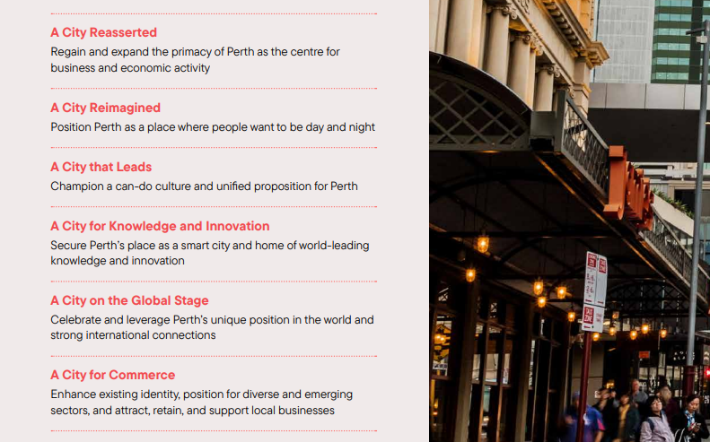
Source: City of Perth, Economic Development Strategy 2022-2032

City of Wanneroo (Western Australia)
The City of Wanneroo have included six strategies to deliver the vision and goals set out in Appendix B. The six strategies are shown below.
(https://www.wanneroo.wa.gov.au/download/downloads/id/4537/economic_development_strategy_-_2022_to_2032.pdf)
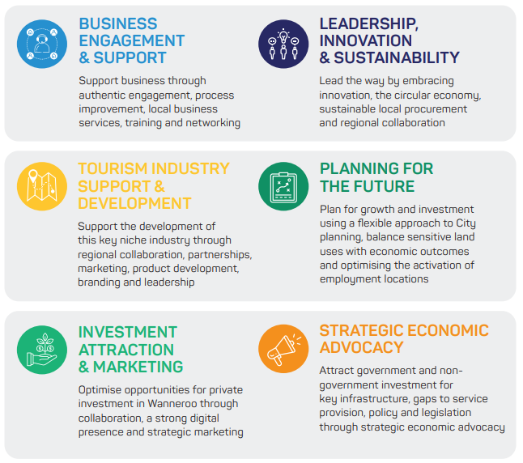
Source: City of Perth, Economic Development Strategy 2022-2032

Economic Development Goals ‘Focus areas’: East Gippsland Shire Council (Victoria)
The East Gippsland Shire Economic Development Strategy (2023) illustrates the ‘focus area’ approach to articulating strategies. It identifies the following themes:
1. Fostering business
2. A high value and sustainable food and fibre sector
3. A unique and compelling tourist destination
4. An economy for young and future generations
5. Digital skills and connections
6. Arts, culture and heritage
7. Living is easy
8. Climate action leaders
9. A circular economy
See https://global-uploads.webflow.com/5f10ce18aa01d050c26b7c5e/6465cb663e80d1f8b11a189e_Economic%20Development%20Strategy%20-%20EGSC_DIGITAL.pdf

Community Wealth Building
The Centre for Local Economic Strategies (CLES) in the UK has identified 5 elements for community wealth building. These can serve as a basis for generating substantive strategies or for checking the completeness of strategies identified through other processes or frameworks.
https://cles.org.uk/what-is-community-wealth-building/the-principles-of-community-wealth-building/
(https://sgsep.com.au/publications/insights/the-right-time-for-community-wealth-building-reform-in-australia )

Appendix D: Examples of an economic development action plan

City of Perth
The following extract from the City of Perth Economic Development Strategy illustrates a commonly used format for an action plan. (https://rgcopcorpweb920-cdn-endpoint.azureedge.net/-/media/Project/COP/COP/COP/Documents-and-Forms/Council/Documents/Reports-and-Important-Documents/Economic-Development-Strategy-2022-2032.pdf?rev=291a877456124ccaad4ed1ff72896306&modified=20220812004341)
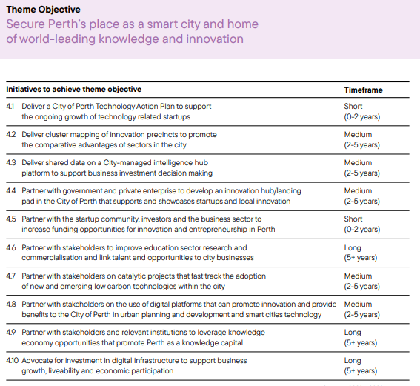

City of Wanneroo (Western Australia)
The following extract from the City of Wanneroo Economic Development Strategy illustrates a simple action plan where one project is highlighted to deliver on each goal. (https://www.wanneroo.wa.gov.au/download/downloads/id/4537/economic_development_strategy_-_2022_to_2032.pdf)
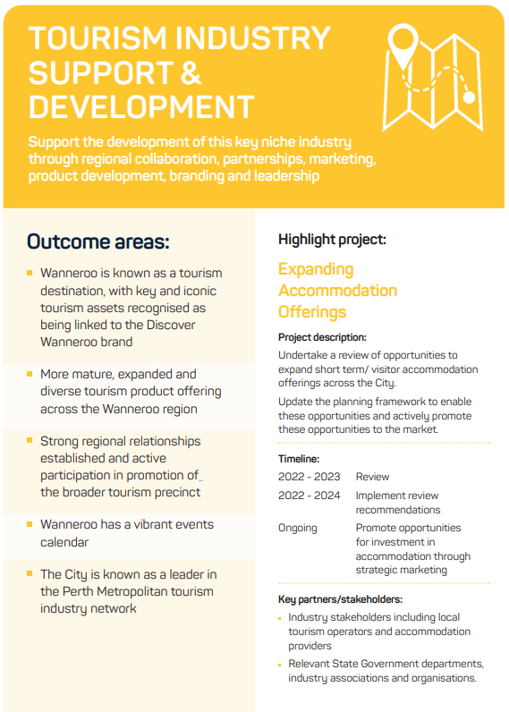

Economic Development Action Plan Example: Golden Plains (Victoria)
The following extract from the Golden Plains Economic Development, Tourism and Investment Attraction Strategy illustrates a commonly used format for an action plan. This provides further detail than the Perth example and includes the relevant arm of Council associated with the action, who will be responsible for leading the action, potential partners for delivering the action and timeframes broken down into the short, medium and long term.
https://www.goldenplains.vic.gov.au/sites/default/files/2022-10/Economic%20Development%20Strategy%202022-2032.pdf
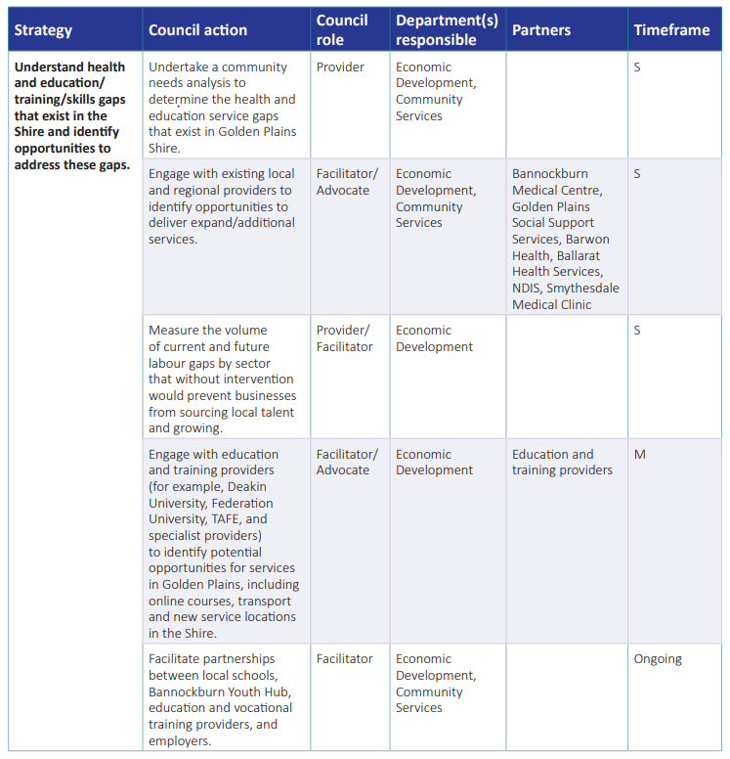

Appendix E: Glossary of technical terms
Anchor Institution: An organization or entity that is deeply rooted and invested in the local community, contributing significantly to its economic and social development.
Circular Economy: An economic model that promotes the reduction, reuse, and recycling of resources to minimize waste and achieve sustainable development.
Competitive Advantage: Refers to the unique attributes or factors that give a region or business a comparative advantage over others in the market.
Economic Development Strategy (EDS): A comprehensive plan designed to guide and promote economic growth, development, and improvement in a specific region or municipality. It outlines the goals, objectives, and strategies to be implemented over a specified time frame.
Economic Resilience: The ability of an economy to withstand and recover from economic shocks or downturns while maintaining its long-term growth and stability.
Employment by Sector: Refers to the distribution of the workforce across various industries or economic sectors, such as agriculture, manufacturing, services, etc.
Exports and Imports: Exports are goods and services produced locally and exported out of the LGA, while imports are goods and services purchased from outside the LGA and consumed domestically.
Female and Male Participation Rates: Measures the percentage of the female and male population that is either employed or actively seeking employment, commonly expressed as the labor force participation rate.
Globalization: The process of increased integration and interdependence of economies and cultures on a global scale, facilitated by advances in communication, transportation, and technology.
Gross Domestic Product (GDP): The monetary value of all goods and services produced within a country's borders over a specific period, usually a year. It is a key indicator of a nation's economic performance.
Gross Value Added (GVA): A measure of the total value of goods and services produced in a specific region or municipality. It includes the income generated by employees and businesses within that area.
Household Income: The total income earned by all members of a household, including wages, salaries, pensions, rental income, and other sources of income.
Location Quotient: A statistical measure used to assess the concentration or specialization of a specific industry in a particular region compared to a reference area, usually the larger region or the entire country.
Multiplier Effect in Economics: The concept that an initial injection of spending in an economy creates a chain reaction of additional spending, leading to a larger overall impact on economic output.
Outsourcing and On-shoring: Outsourcing involves contracting out specific business processes or services to external service providers, often overseas. On-shoring refers to the opposite, bringing those services back to the home country.
Resource Requirement: The amount of resources, including funding, personnel, and materials, needed to implement specific actions or strategies.
Social Cohesion: The degree of unity, cooperation, and trust among members of a society, leading to the overall stability and well-being of the community.
Strategic Direction: The overall vision, objectives, and long-term goals that guide an organization or region's decisions and actions.
Strategic Community Plan: A plan developed by local governments to address the needs and aspirations of the community. It serves as a roadmap for future development and guides the Council's approach to planning and decision-making.
Supply Chain Unbundling:
The process of breaking down complex supply chains into smaller, specialized components, often involving outsourcing or offshoring certain production processes.
Sustainable Development Goals (SDGs): A set of 17 global goals established by the United Nations to address global challenges, including poverty, inequality, climate change, and sustainable economic development.
SWOT Analysis: A strategic planning tool used to identify the strengths, weaknesses, opportunities, and threats of an organization or a region. It helps to assess the internal and external factors that may impact the achievement of objectives.
Transformational Change: A significant and fundamental shift in the structure, systems, or operations of an organization, region, or economy, often aimed at achieving radical improvement or adaptation to new circumstances.
Triple Bottom Line: An approach that considers three key dimensions in decision-making: economic, social, and environmental factors. The goal is to achieve a balance between economic growth, social well-being, and environmental sustainability.

